Plate 1. Disease development on artificial inoculation with post harvest pathogens on 24th day of storage

Plate 1. Disease development on artificial inoculation with post harvest pathogens(24th day of storage)

Erwinia
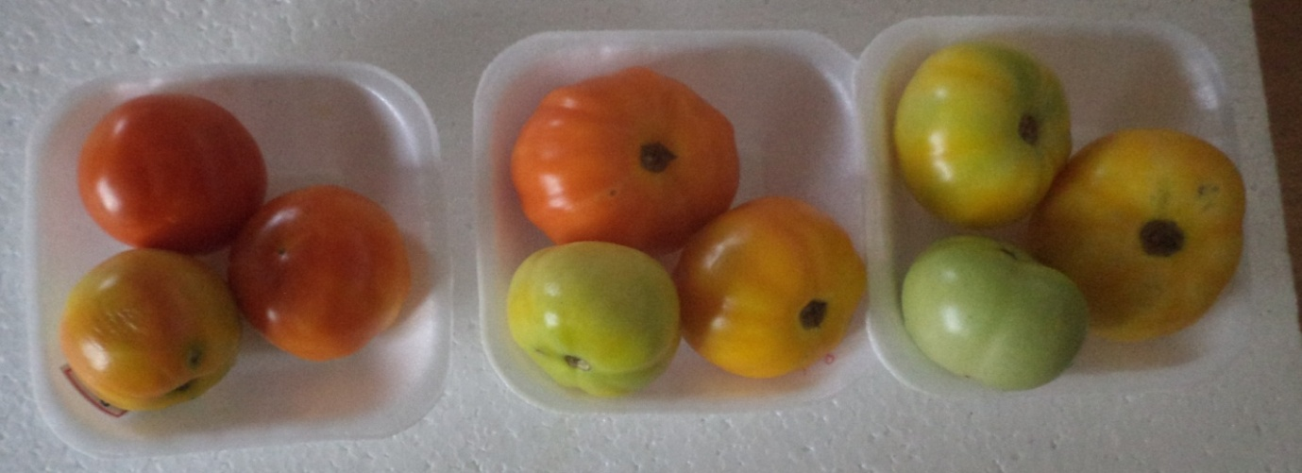
PLEAG
Control
Aloe gel

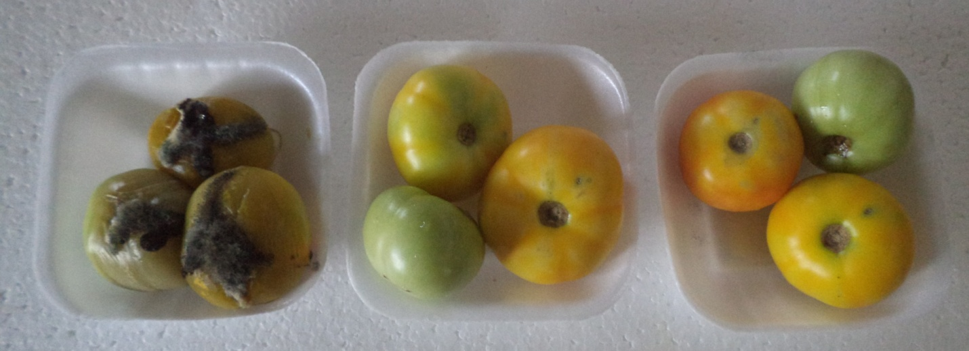
Rhizopus

PLEAG
Aloe gel
Control

