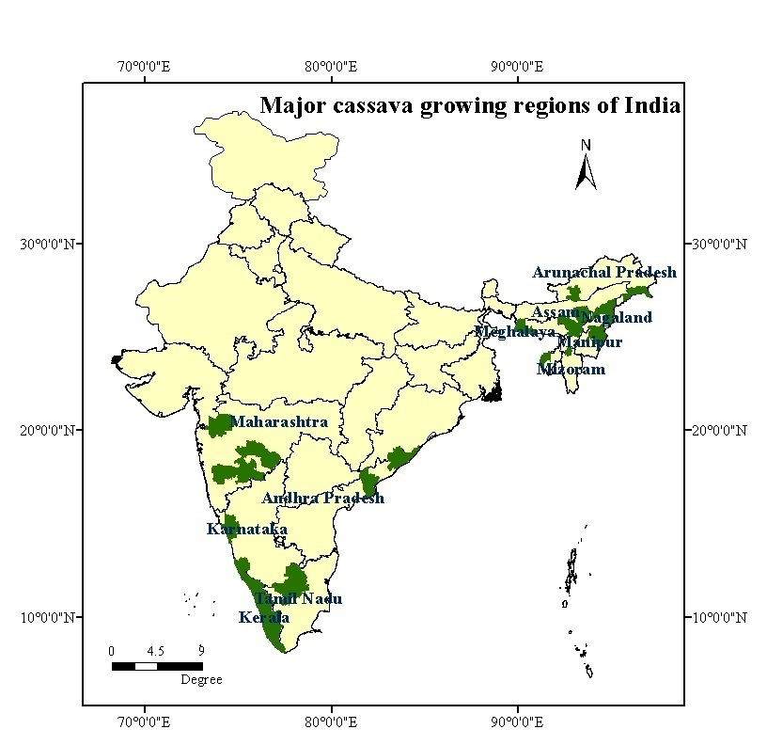

Figure 1. Presence points map of major cassava growing regions in India
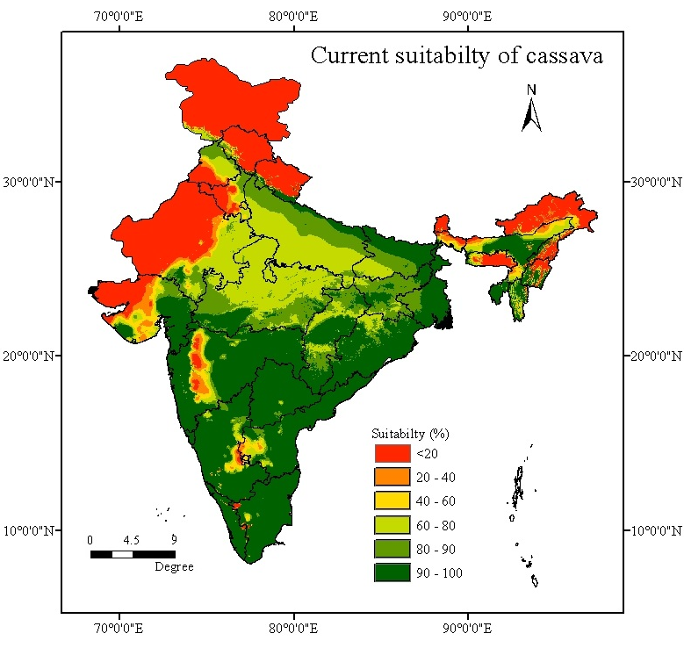
Figure 2. Current climate suitability of cassava by EcoCrop model

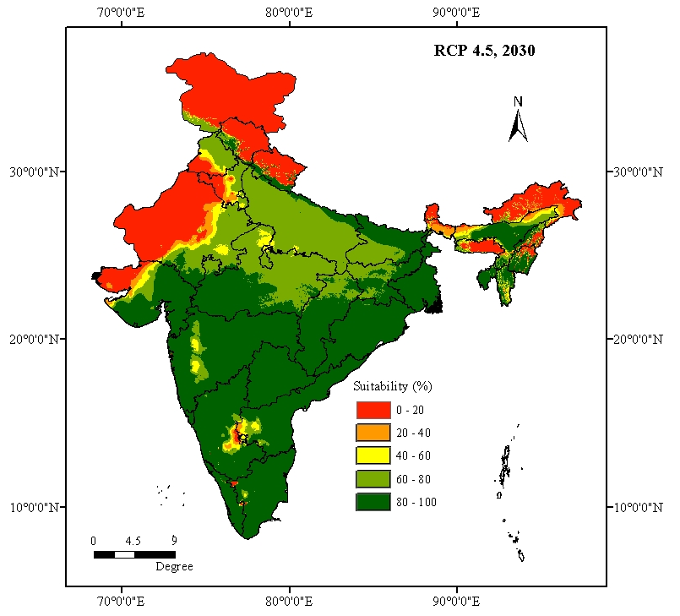 | 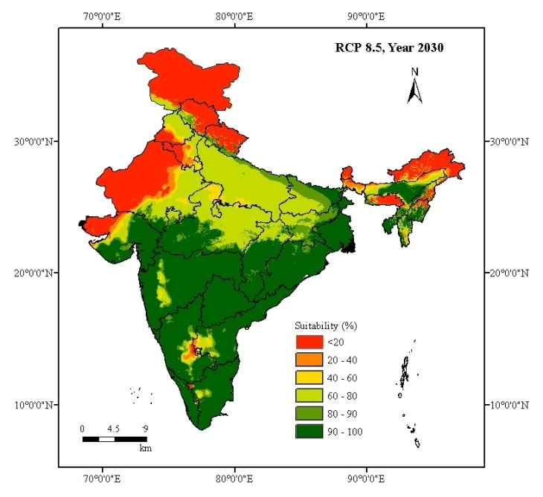
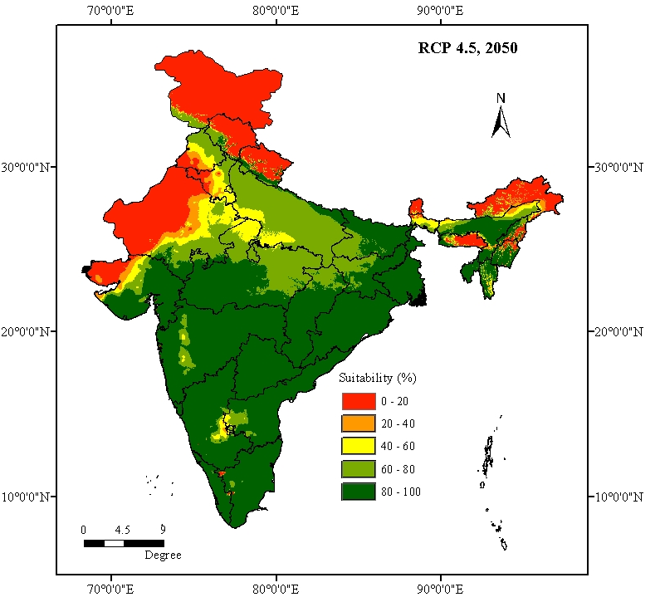 | 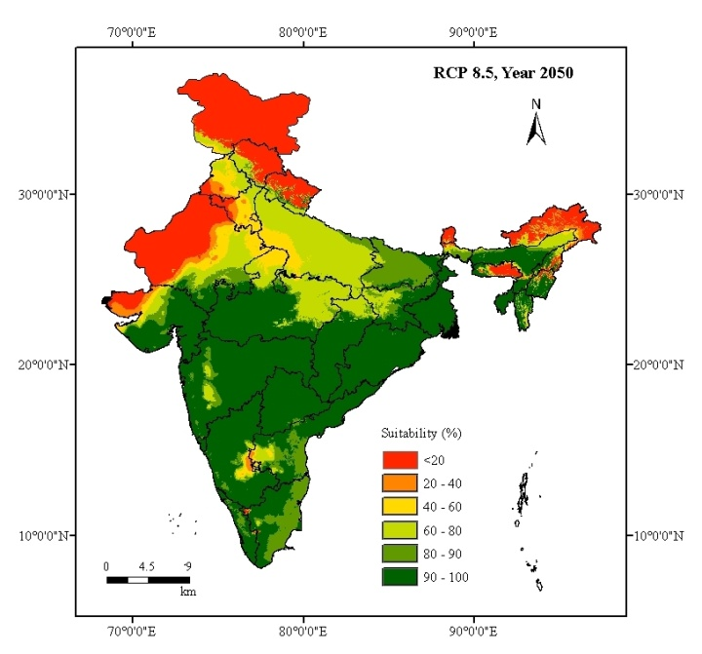

Figure 3. Predicted future suitabilities of cassava as average of the 10 GCMs studied

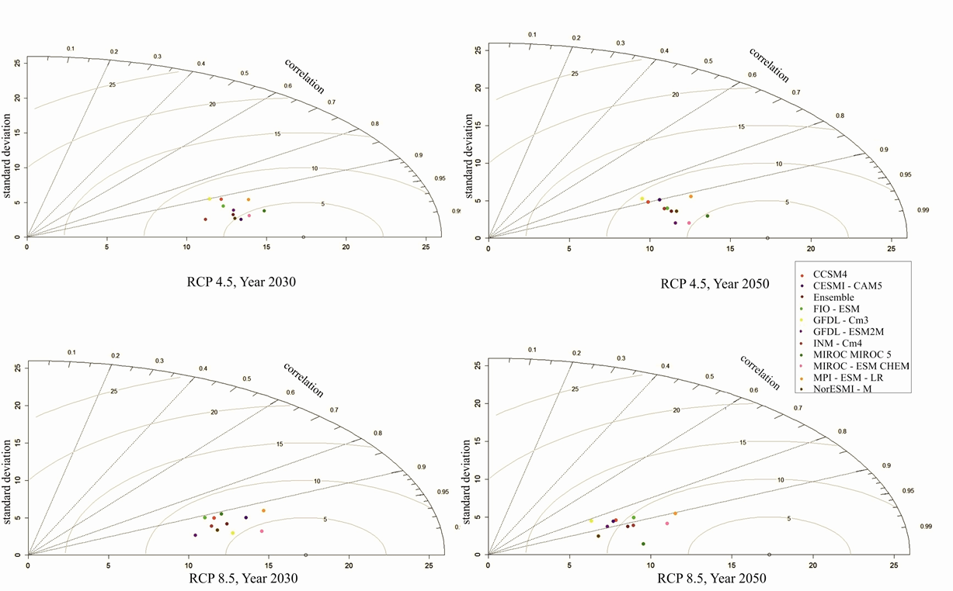

Figure 4. Taylor diagram showing relation between current suitability and predicted future suitability by each model

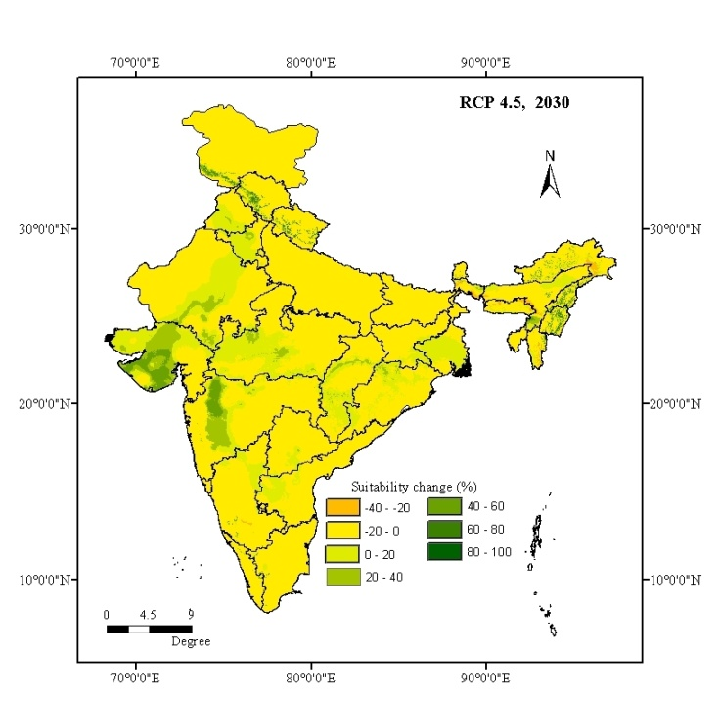 | 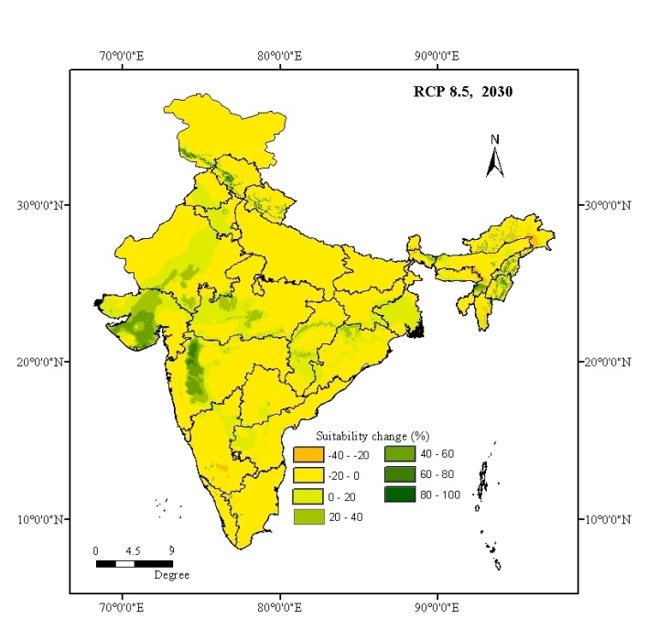
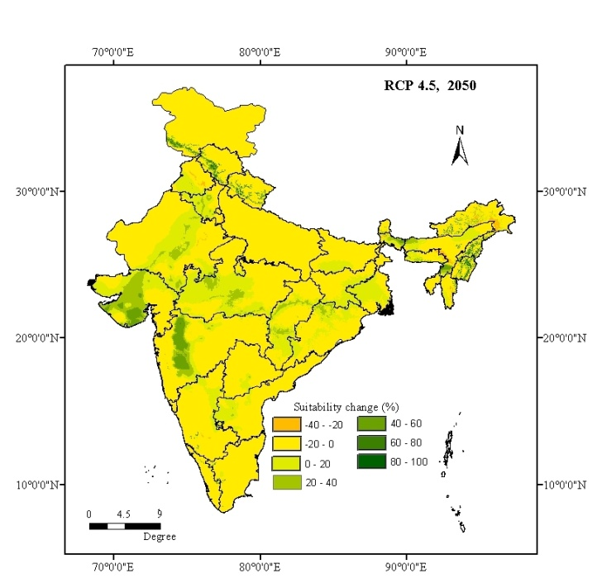 | 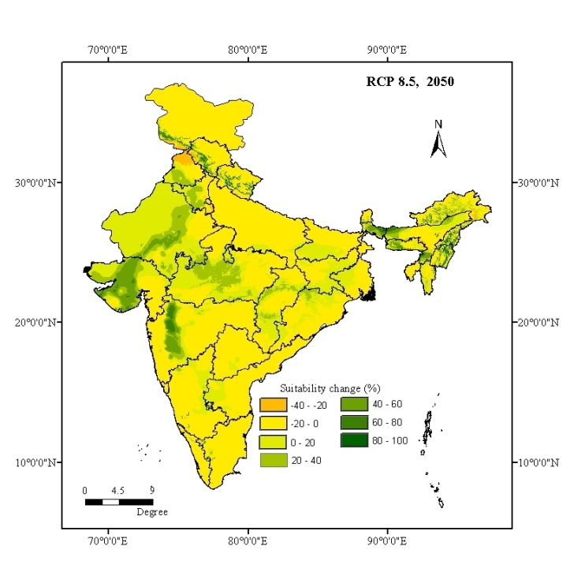
Figure 5. Changes in cassava climate suitability as average of the 10 GCMs studied

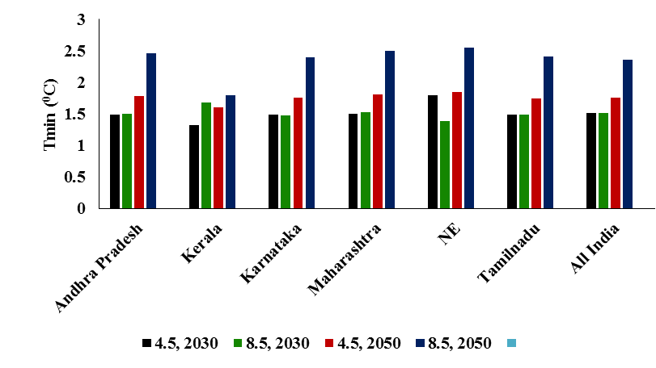 | 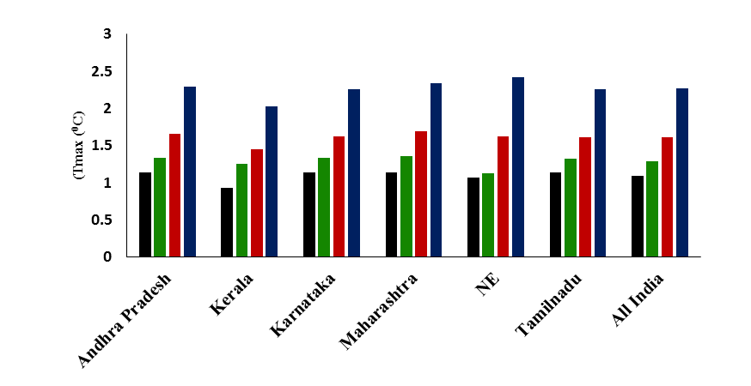
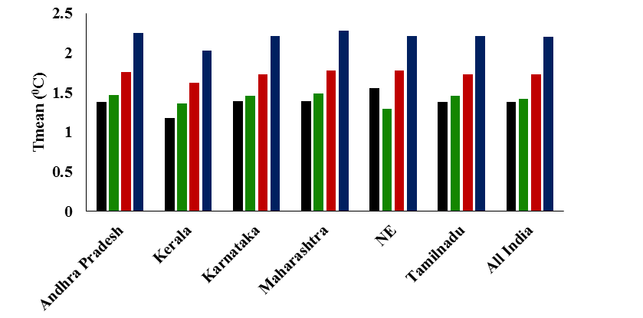 | 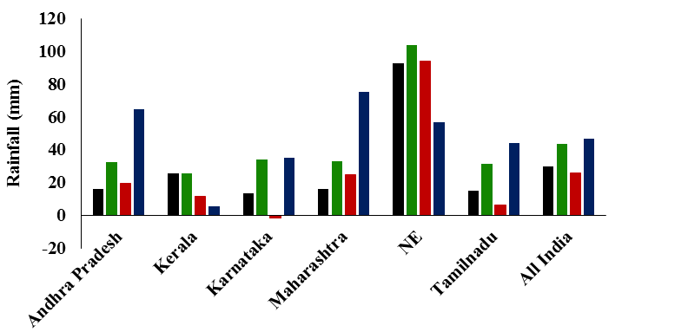
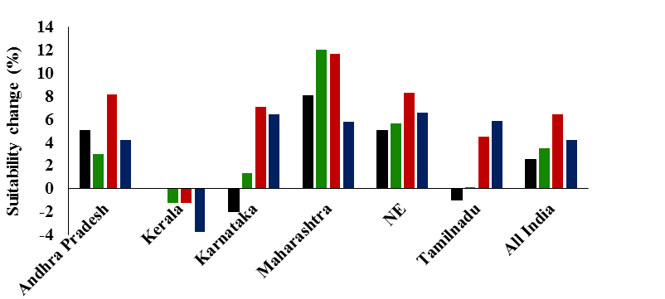
Figure 6. Change in climate and climate suitability in cassava growing regions

Table 1. Details of the coupled model inter-comparison project 5 (CMIP5) models selected for the study
Sl. No. | Model | Spatial Resolution  (Long ⁰ x Lat ⁰ ) | Modelling Centre | Country
1 | CCSM4 | 1.25 x 0.9424 | National Centre for Atmospheric Research | USA
2 | CESMI-CAM5 | 1.25 x 0.9424 | National Centre for Atmospheric Research | USA
3 | GFDL-CM3 | 2.5 x 2 | NOAA Geophysical Fluid Dynamics Laboratory | USA
4 | MIROC-ESM CHEM | 2.8125 x 2.7673 | Atmosphere and Ocean Research Institute, National Institute for Environmental Studies, Japan Agency for Marine-Earth Science and Technology | Japan
5 | NorESMI-M | 2.5 x 1.8947 | Bjerknes Centre for Climate Research Norwegian Meteorological Institute | Norway
6 | INM-CM4 | 2 x 1.50 | Institute for Numerical Mathematics | Russia
7 | GFDL-ESM2M | 2.5 x 1.5169 | NOAA Geophysical Fluid Dynamics Laboratory | USA
8 | FIO-ESM | 2.815 x 2.7673 | The First Institute of Oceanography, | China
9 | MIROC MIROC 5 | 1.4063 x 1.389 | Atmosphere and Ocean Research Institute, National Institute for Environmental Studies, Japan Agency for Marine-Earth Science and Technology | Japan
10 | MPI-ESM-LR | 1.25 x 0.9424 | Max Planck Institute for Meteorology | Germany

Table 2. Ecological parameters used to calibrate the EcoCrop model for cassava
Sl.No | Parameter | Calibrated value
1 | Tkill | 5 ⁰C
2 | Tmin | 18 ⁰C
3 | Tmax | 48 ⁰C
4 | Topmin | 20 ⁰C
5 | Topmax | 30 ⁰C
6 | Rmin | 400 mm
7 | Ropmin | 600 mm
8 | Ropmax | 2000 mm
9 | Rmax | 3300 mm
Source: Sabitha et al., 2016

Table 3. Predicted climate change in major cassava growing regions of India

 | Tmin (⁰C) |  |  |  | Tmax (⁰C) |  |  |  | Tmean (⁰C) |  |  |  | Rainfall (mm)
RCP | 2030 |  | 2050 |  | 2030 |  | 2050 |  | 2030 |  | 2050 |  | 2030 |  | 2050
Year | 4.5 | 8.5 | 4.5 | 8.5 | 4.5 | 8.5 | 4.5 | 8.5 | 4.5 | 8.5 | 4.5 | 8.5 | 4.5 | 8.5 | 4.5 | 8.5
Andhra Pradesh | 1.49 | 1.5 | 1.78 | 2.46 | 1.14 | 1.34 | 1.66 | 2.30 | 1.38 | 1.47 | 1.76 | 2.25 | 15.95 | 32.32 | 19.66 | 64.73
Kerala | 1.32 | 1.68 | 1.60 | 1.79 | 0.93 | 1.26 | 1.45 | 2.03 | 1.18 | 1.36 | 1.62 | 2.03 | 25.66 | 25.27 | 11.32 | 5.31
Karnataka | 1.49 | 1.47 | 1.75 | 2.40 | 1.14 | 1.34 | 1.63 | 2.26 | 1.39 | 1.46 | 1.73 | 2.21 | 13.57 | 34.02 | -1.91 | 35.13
Maharashtra | 1.50 | 1.52 | 1.81 | 2.50 | 1.14 | 1.36 | 1.69 | 2.34 | 1.39 | 1.49 | 1.78 | 2.28 | 16.07 | 32.79 | 24.58 | 75.13
NE | 1.80 | 1.39 | 1.85 | 2.55 | 1.07 | 1.13 | 1.62 | 2.42 | 1.55 | 1.29 | 1.78 | 2.21 | 92.40 | 103.70 | 93.90 | 56.60
Tamil Nadu | 1.49 | 1.49 | 1.74 | 2.41 | 1.14 | 1.33 | 1.61 | 2.26 | 1.38 | 1.46 | 1.73 | 2.21 | 14.68 | 31.32 | 6.40 | 44.01

Table 4. Correlation and standard deviation of predicted current climate suitability and future suitability of each models in major growing areas of cassava
Sl.No | Model | Correlation |  |  |  | Standard deviation
 |  | 2030 |  | 2050 |  | 2030 |  | 2050
 |  | 4.5 | 8.5 | 4.5 | 8.5 | 4.5 | 8.5 | 4.5 | 8.5
1 | CCSM5 | 0.913 | 0.919 | 0.899 | 0.865 | 13.326 | 12.605 | 10.994 | 9.085
2 | CESMI-CAM5 | 0.982 | 0.938 | 0.901 | 0.866 | 13.642 | 14.476 | 11.759 | 8.879
3 | FIO-ESM | 0.939 | 0.909 | 0.941 | 0.875 | 13.082 | 12.107 | 11.777 | 10.222
4 | GFDL-CM3 | 0.901 | 0.974 | 0.874 | 0.816 | 12.677 | 13.097 | 10.896 | 7.756
5 | GFDL-ESM2M | 0.957 | 0.968 | 0.985 | 0.891 | 13.493 | 10.749 | 11.759 | 8.211
6 | INM-CM5 | 0.975 | 0.947 | 0.94 | 0.915 | 11.466 | 12.071 | 11.578 | 9.742
7 | MIROC MIROC 5 | 0.969 | 0.909 | 0.977 | 0.989 | 15.329 | 13.253 | 13.891 | 9.643
8 | MIROC-ESM CHEM | 0.976 | 0.976 | 0.987 | 0.935 | 14.264 | 14.907 | 12.596 | 11.765
9 | MPI-ESM-LR | 0.932 | 0.926 | 0.914 | 0.904 | 14.876 | 15.831 | 13.715 | 12.741
10 | NorESMI-M | 0.979 | 0.962 | 0.955 | 0.938 | 13.286 | 12.254 | 12.198 | 7.222

Table 5. Regional changes in cassava climate suitability for individual GCMs studied
GCM | RCP 4.5, Year 2030 |  |  | RCP 8.5, Year 2030 |  |  | RCP 4.5, Year 2050 |  |  | RCP 8.5, Year 2050
GCM | OSC* | SCPIA* | SCNIA* | OSC | SCPIA | SCNIA | OSC | SCPIA | SCNIA | OSC | SCPIA | SCNIA
CCSM4 | 6.21 | 36.83 | -8.37 | 6.68 | 36.83 | -7.88 | 8.30 | 38.18 | -6.59 | 9.46 | 42.82 | -6.43
CESMI-CAM5 | 3.62 | 33.81 | -13.16 | 4.48 | 33.65 | -10.41 | 7.42 | 39.52 | -8.43 | 9.87 | 41.08 | -5.41
GFDL-CM3 | 6.15 | 33.68 | -5.97 | 3.71 | 28.51 | -9.23 | 7.01 | 37.86 | -7.09 | 8.66 | 43.24 | -8.32
MIROC ESM-CHEM | 3.15 | 27.72 | -9.07 | 0.87 | 21.27 | -10.11 | 3.91 | 29.15 | -8.74 | 6.17 | 36.54 | -6.51
NorESMI-M | 4.21 | 21.70 | -5.79 | 5.13 | 33.82 | -9.95 | 5.27 | 31.67 | -7.56 | 7.86 | 39.22 | -8.18
INM-CM4 | 6.50 | 34.08 | -8.00 | 5.43 | 33.44 | -8.58 | 7.19 | 38.99 | -7.54 | 8.71 | 40.04 | -6.65
GFDL-ESM2M | 4.59 | 33.75 | -8.36 | 6.47 | 34.42 | -6.89 | 4.32 | 29.22 | -8.70 | 7.84 | 40.07 | -7.98
FIO-ESM | 4.53 | 35.47 | -8.90 | 7.00 | 39.40 | -7.03 | 5.70 | 36.02 | -7.32 | 7.87 | 42.14 | -8.99
MIROC MIROC 5 | -3.49 | 30.14 | -16.06 | 5.15 | 38.73 | -10.08 | 0.65 | 30.30 | -13.36 | 3.68 | 31.38 | -9.02
MPI-ESM-LR | 3.94 | 31.97 | -8.58 | 2.89 | 33.87 | -12.66 | 5.78 | 37.37 | -12.67 | 6.51 | 38.22 | -9.83
Mean | 3.94 | 31.92 | -9.23 | 4.78 | 33.39 | -9.28 | 5.56 | 34.83 | -8.80 | 7.66 | 39.48 | -7.73
OSC* - Overall suitability change, SCPIA - Suitabilty change in positively impacted areas,
SCNIA - Suitabilty change in negatively impacted area.

