Leaf epidermal morphology and petiole anatomy of the genus Anthocleista Afzel. ex R.Br. (Gentianaceae)

Muhali Olaide Jimoh¹, James Dele Olowokudejo
Botany Department, University of Fort Hare, Alice 5700, South Africa
¹ corresponding author’s email- moajay006@gmail.com / 201700424@ufa.ac.za

ABSTRACT
Morphology of leaf epidermis and petiole transverse section in three species of Anthocleista was studied using a Light microscope with a view to reviewing the systematic significance of epidermal morphology and petiole anatomy in the genus. Interestingly, important taxonomic characters such as epistomata were observed in A. vogelii and amphistomata in A. djalonensis and A. nobilis. Scale trichomes were found in both epidermal layers of A. djalonensis and glandular trichome, which is multicellular and unicellular in A. nobilis and A. djalonensis respectively. Stomatal Index was highest at adaxial of A. nobilis (10.14%), lowest at A. djalonensis (4.56%) and did not exist at all at the abaxial surface of A. vogelii. Common generic characteristics are polygonal cell shape, straight anticlinal wall, dendritic trichomes and petiole anatomy. The petiole is longest in A. nobilis, short in A. djalonensis and absent in A. vogelii. This work therefore, revealed that species in the genus differ in epidermal characteristics which could be used to delimit them although they share some similarities in cell geometry, petiole transverse section and anticlinal walls; all these are important taxonomic tools used in delimiting species in the genus.
Keywords: morphology, Anthocleista, stomatal index, anticlinal wall, dendritic trichomes

INTRODUCTION
The Genus Anthocleista Afzel. ex R. Br. (Gentianaceae) is a dicot genus consists of approximately fifty species worldwide and fourteen species in tropical Africa including Comoros, Madagascar and Mascarene Island. Members are mostly trees and shrubs, usually with woody stem (Palmer & Pitmer 1972, Keay 1989, Leeuwenberg & Leehourts 1980, Struwe & Albert 2002, Sonibare et al. 2007, Hyde 2013,). Leaves are opposite, simple, stipulate or estipulate. Flowers are hermaphroditic, usually actinomorphic with 2-4 celled superior ovaries. Fruit may be capsule, drupe or berry. Their leaves are glabrous, leathery and large and are often over 1 ft long in mature trees and up to 5 ft long in saplings. The base of the leaf stalk is dilated and sometimes more or less winged. The leaves of these species range from obovate to oblanceolate shapes and are clustered at the ends of the branchlets, mostly 6-18 inches long; and the flowers 1-3 inches long. The flower colour ranges from white to cream in A. djalonensis and A. nobilis while it is orange or fawn colour in A. vogelii (Leeuwenberg & Leehourts 1980, Hutchinson & Dalziel 1994, Burkill 1995, Burkill et al. 1995, Edwin-Wosu et al. 2012).
Species in this genus include:
- A. amplexicaulis Baker
- A. djalonesis A. chev.
- A. exelliana Th. Monod
- A. grandiflora
- A. keniensis
- A. liebrechstiana
- A. madagascariensis
- A. nobilis G. Don
- A. procera
- A. rhizophoroides Baker
- A. scandens
- A. schweinfurthii
- A. vogelii
- A. zambesiaca
The four species occurring in West Africa have the same vernacular names and are used by local practitioners for the same medicinal purposes (Dalziel, 1954, Leeuwenberg 1961, Watt & Breyer-Brandwijk, 1962, Chapelle 1976, Adjanohoun et al 1979, Akubue Et Al 1983, Abbiw 1990, Antia Et Al 2009; Ateufack et al. 2006, Burkill 1995, Neuwinger 2000, Togola et al. 2005, Sonibare et al. 2007, Mabberley 2008). The description of their phytochemical evaluation by Sonibare et al.⁴² and other researchers was elaborate and from available reports, they almost share the same phytochemical contents and medicinal properties (Githens, 1949, Antia et al. 2009, Bierer et al. 1995, Onocha & Okorie 1995, Jensen & Schripsema 2002, Onocha et al. 2003, Okoli & Iroegbu, 2004, Campaner dos Santos et al. 2005, Chah et al. 2006, Olowokudejo 2008, Odeghe et al. 2012). Because of uncontrolled harvesting for use in local medicine, species are threatened by overexploitation in Mali and Burkina Faso. A concerted effort should, therefore, be undertaken to conserve the species (Leeuwenberg 1961).

Nine species were recorded in West Tropical African region (Burkill 1995, Oduoye 2013) out of which four is reported in Nigeria. Three of these species: A. djalonensis, A. vogelii and A. nobilis are abundant and widespread in the South Western region. They are usually small trees or scrambling shrubs with soft white wood (Sonibare et al. 2007). Menninger (1967) averred that nearly all have vicious forking thorns, adding that at a certain stage in their development; they lose their bark and leaves, but retain their thorns on the trunk and come to resemble a thorny naked pole. However, the wider literature suggests that the thorns are not always present (Leeuwenberg 1961, 1983, 1992, Leeuwenberg & Leehourts 1980, De Ruijter 2007)

Anthocleista is faced with problems of classification. One of the historic problems with classifying this genus under Loganiaceae family was that most taxon assigned to this family had rather generalized or plesiomorphic traits (Leeuwenberg & Leehourts 1980, Mabberley, 2008). The genus had in the past been classified in the Potaliaceae and in the Loganiaceae but data from phylogenetic studies in 1990 and subsequently, the Angiosperm Phylogeny Group (Angiosperm Phylogeny Group 2003) has now been placed the genus in the Gentianaceae.

Due to its possession of supermerous corollas and seminal parts, Anthocleista was believed to have diverged from the gentian flora as it appears to lack post genital fusion of carpels which is typical to gentians. So it was concluded that Anthocleista is a tropical woody genus with showy flowers and fleshy or leathery berries, whereas most gentians are smaller herbs or shrubs with dry capsular fruits (Struwe & albert 2002). The core objective of this study was to examine morphological characteristics of the species vis a vis their leaf epidermis and anatomy of their petiole in order to re-evaluate the taxonomic significance of structures observed. The study also assisted in reviewing available taxonomic data of the species and in re-evaluating key structures responsible for species characterization.
Materials and methods
Mature and fresh leaves of Anthocleista species were collected from trees (Table 1; plate 1-3). A. djalonensis and A. nobilis were collected at different locations in Abeokuta while A. vogelii was collected in the University of Lagos, southwestern Nigeria (Table 1). The three species were deposited in Lagos University Herbarium for verification.

Epidermal preparation and petiole transverse section
About 3cm² portions of the leaf were cut off with a razor blade and leaf pieces were boiled in water for 7-10 mins and then irrigated in concentrated Hydrogen Tetraoxonitrate (V) acid (HNO₃) for 8-10 hrs in covered specimen bottle to macerate the mesophyll. The appearance of bubbles around treated leaf indicated tissue disintegration and the epidermises were subsequently transferred into cold water inside Petri dishes for separation using forceps and mounting needle. The tissue debris was removed from the epidermises and washed in several changes of water with a soft brush. Few drops of ethanol were added to dehydrate the cells or harden it and stained with 3-4 drops of Safranin O before mounting in glycerine with outer surfaces uppermost on a glass slide. The treated cells were covered with glass coverslips and ringed with a lacquer to prevent dehydration and exposure to the atmosphere. This epidermal preparation method follows the method employed by Kadiri & Olowokudejo, 2010.

For petioles, about 0.1-0.2mm were carefully sliced with a razor blade and soaked in sodium hypochlorite for 5minutes to bleach them, then transferred to Petri dishes of distilled water. The preparations were dehydrated on a glass slide for about 3 minutes by adding few drops of ethanol and then stained in Safranin O for five minutes before being mounted in glycerin on glass slides. The slides were ringed with varnish to cover them (Kadiri & Olowokudejo 2010, Illoh & Inyang 1998).
Thereafter, slides were labeled accordingly and examined with a Zeiss Light Microscope; model Axio Lab A.1 at different magnifications (x4, x10, x40 and x100). Photomicrographic images of examined cell features were taken digitally with a motic image plus version 2.0ml embedded on the light microscope. This work was carried out in the Botany Research Laboratory, University of Lagos, Akoka Nigeria.
Macromorphological studies
Leaves of the three species were cross-examined physically to obtain macromorphological characteristics of the species and compared them critically vis a vis leaf length, leaf apex type, leaf base form, presence or absence of petiole and its length, the nature of petiole base at the point of attachment to the stem. This was carried out with the aid of a calibrated ruler and measurements were taken in centimetre.
Micromorphological examinations
Morphological study of the leaf epidermal layers was carried out to observe both qualitative and quantitative characters of the adaxial and abaxial surfaces. Qualitative characters include; stomatal type, epidermal type, trichomes, cell geometry, anticlinal wall pattern. The quantitative characters examined were; epidermal cell wall thickness, stomatal length, epidermal cell length, number of stomatal per field of view and number of epidermal cells per field of view. With the aid of micrometer eyepiece, quantitative characters were measured and mean values recorded for comparative analysis.
Character analysis
Twenty epidermal cells were counted and selected randomly and their lengths, widths, wall thickness were measured. For stomata, five cells were selected randomly and measured to obtain their lengths and width using micrometer eyepiece while the number in the field was counted in ten views per species.

Petiole anatomy
The internal structure of the petiole was examined to compare arrangement of the vascular bundle and association of tissues in the three species. A number of vascular bundles were counted per field of view as well as mean vessel number per vascular bundle.

RESULTS
Leaf epidermal morphology and petiole anatomy of Genus Anthocleista was carried out to investigate characters of taxonomic importance that are common to all or distinguished the species from one another. Tables 2-7 present morphological features observed in the leaves and a transverse section of the petiole.
Macromorphological studies
Morphologically, A. djalonensis, A. vogelii and A. nobilis are closely related. They all have spines and white flowers but A. vogelii is practically stalkless while A. djalonensis and A. nobilis are distinctly stalked. In all, leaves are opposite, simple and entire. The petiole is auricled and about 6-7cm long in A. djalonensis. Leaf apex of A. djalonensis is rounded with the cordate base; mature leaf blade is about 15-18cm long, 10-12cm broad. Leaf base is cuneate, apex rounded in A. vogelii. Mature leaf length is about 32-36cm, 17-22cm broad. In A. nobilis, leaf blade is usually 23-47cm long, 13-22cm broad; rounded or bluntly pointed at the apex, tapering gradually to a cuneate or oblique base; light green abaxial and dark green adaxial surfaces crowded at the apices of the branchlets. The petiole is 13-15cm long in A. nobilis and dilated at the base for the three species.

Epidermal and stomatal cell features
The three species namely; A. djalonensis, A. nobilis and A. vogelii exhibited polygonal cell shape on both layers (plates 4a-6b). Some triangular cell shapes were observed, especially in A. djalonensis (adaxial). Anticlinal wall pattern is straight in all but bent walls were seen, especially in cells surrounding guard cells (Table 2). The Abaxial surface of A.vogelii has the greatest number of epidermal cells (260) due to absence of stomatal followed by A. djalonensis (adaxial; 243), A. nobilis (adaxial; 229), A. djalonensis (abaxial; 215), A. vogelii (adaxial; 200) and A. nobilis (abaxial; 186). This is presented in Table 4 below.

Presence of scale was also observed on both surfaces of A. djalonensis and A. nobilis but absent in A. vogelii. Unicellular glandular trichomes were observed in the abaxial surface of A. vogelii. This peculiar feature was not seen at its adaxial surface as only unicellular dendritic trichomes were observed. At both surfaces of A. djalonensis, dendritic, tubular, and unbranched and prominent scale trichomes were found. For A. nobilis, trichomes were scaly and dendritic. Also, typical multicellular glandular trichomes were observed at the adaxial surface of A. nobilis (Table 2). While only A. vogelii was observed to be epistomatic, A. djalonensis and A. nobilis were amphistomatic. The mean stomatal number (18.4) was highest in A. nobilis (adaxial) followed by A. vogelii (adaxial; 15.95), A. djalonensis (abaxial; 13.6), A. nobilis (abaxial, 13.4), A. djalonensis (adaxial; 10.1) while no stomatal was recorded in A. vogelii (abaxial), (Table 3). Longest stomata were recorded on the adaxial surface of A. djalonensis (20.85 µm length; 13.7µm Width), followed by A. nobilis (19µm; 11µm Width), and A. djalonensis (14.7µm

Petioles
The three species showed a high level of resemblance in the configuration of different tissues, making the petiole (Plates 7a-9c). The transverse sections clearly revealed scattered vascular tissues in the parenchymal cells of the central cylinder, vascular bundles numbering 8-10, each containing 5-9 tracheids in the xylem. Tannin is present and abundant in the three species and this is reddish in colour. Apart from the scattered vascular bundle in the central cylinder, a circular ring was formed around the parenchyma cells by another set of bundles (Plates 7a-9c).

DISCUSSION
The problem of classification is historic with Anthocleista spp. (Leeuwenberg & Leehourts, 1980, Mabberley 2008). As a result, the genus was placed in different families such as Loganaceae, Potaliaceae and Gentianaceae in the past on the account of plesiomorphic traits, the most recent being Gentianaceae based on account of phylogenetic studies proposed by the Angiosperm Phylogeny Group⁴. This averred the need for critical studies of other parts of the plant particularly, the aerial parts to unravel more characters of taxonomic significance in order to achieve a robust character database for the plant species and to make delineation seamless.
This study showed that there are some variations in leaf morphological characters of Anthocleista species. Though they share many characters in common, some characters vary considerably between and within species of this genus. The distribution of the species in the West African region has been described by Burkil⁸ and their biosystematic studies have been discussed by Edwin-Wosu et al. 2012. Also, their phytochemical analysis (though out of the scope of this work) has been investigated and widely communicated by Akubue et al. (1983), Haslam (1981) and Neuwinger (2000), however, Sonibare et al. (2007) discussed in detail, a chemotaxonomic approach to the alkane content of the three species under study.

In the three species studied elongated trichomes which differ in form, size, length, and density; depending on the species were observed. Stace (1965) suggested that hairs are constant in a species when present and showed a constant range of form and distribution useful in diagnosis while Metcalfe & Chalk (1950) on the other hand reported that the length, size and trichome density are more liable to vary with the environment. A. nobilis and A. djalonensis for example, have glandular trichome while the scale and stellate trichomes were prominent in both epidermal surfaces of A. djalonensis. Dendritic trichome is common to the three species, suggesting a morphological relationship.

Observations further revealed different types of stomatal among species in the genus. This could be used as a key taxonomic factor in delimiting the species. Since A. vogelii was observed to have paracytic stomata at the adaxial surface only (epistomatic), A. djalonensis possesses Cyclocytic stomata at both surfaces while A. nobilis differs by possessing anomocytic and Actinocytic stomata at the adaxial and abaxial surfaces respectively. This finding, however, agrees with Edwin-Wosu¹⁶ on stomatal variation in Anthocleista and may be used as a key factor in delimiting the species, though Metcalfe & Chalk (1950) stated that stomata of more than one type occur together sometimes on the same leaf surface or stomata on the upper and lower surfaces may differ, therefore, not all stomata present on a leaf are good example of a single type and a fairly large number of stomata should be considered to determine the prevalent type (Cutler 1969).

The epidermal cells are polygonal in shape with straight anticlinal wall pattern (Oduoye 2013). Stace (1965) considered this feature peculiar to the environment of low humidity but A. nobilis used in this study was collected from a high humid location. The variations seen in the epidermal cell number and size between and within the species may be influenced by external environmental factors (Metcalfe & Chalk 1950) suggesting that values recorded are susceptible to changes.

Worthy of note is the level of resemblance observed in petiole transverse section of the three species. The placement of vascular bundle in the pith; the presence of tannin; tissue arrangement were the same and the cells look alike.

Therefore, it is pertinent to understand that diagnostic morphological and anatomical characters of species of Anthocleista are not the same for all. So, the need to rely on characters of high taxonomic value which status has been established such as those enumerated by Oduoye (2013) in his principal component analysis of nine species of Anthocleista cannot be overemphasized.
CONCLUSION
The genus Anthocleista differ morphologically with regard to epidermal characters, such as cell size, cell number, wall thickness, stomata type, distribution, and index. They exhibit striking similarities in petiole transverse section, cell geometry, and anticlinal walls. These characters can, therefore, be used to either differentiate between and within specific levels or distinguish them from other genera.

Based on results obtained from this study, the artificial indented key to the species is hereby presented.
- Leaf Epistomatic
1a. Paracytic stomata, unicellular glandular trichomes, sessile leaves, ………A. vogelii
- Leaf amphistomatic
2a. Cyclocytic stomata, scale trichomes (abaxial and adaxial), petiole (6-7cm) long……………………………………………………………..………...... A. djalonensis
2b. Anomocytic stomata (adaxial), Actinocytic (abaxial), trichomes; multicellular glandular, scale (abaxial), petiole (13-15cm), stomatal index (10.14%)…...... A. nobilis
REFERENCES
ABBIW DK. 1990. Useful plants of Ghana: West African uses of wild and cultivated
plants. Intermediate Technology Publications, London and Royal Botanic Gardens, Kew, Richmond, United Kingdom. Pp 337. DOI: 10.1017/S0014479700019116
ADJANOHOUN EJ, AKÉ ASSI L, FLORET JJ, GUINKO S, KOUMARÉ M, AHYI
MRA & RAYNAL J. 1979. Médecine traditionelle et pharmacopée - Contribution aux études ethnobotaniques et floristiques au Mali. Agence de Coopération Culturelle et Technique, Paris, France. Pp 29. DOI: 10.4314/afsci.v5i2.61745
AKUBUE PI, MITTAL GC, & AGUWA CN. 1983. Preliminary pharmacological study
of some Nigerian medicinal plants.1. Journal of Ethnopharmacology 8:53-63. DOI:10.1016/0378 8741(83)90089-2
ANGIOSPERM PHYLOGENY GROUP 2003. An update of the Angiosperm Phylogeny
Group classification for the orders and families of flowering plants: APG II. Botanical Journal of the Linnean Society 141(4):399-436. DOI: 10.1046/j.1095-8339.2003.t01-1-00158.x
ANTIA BS, OKOKON JE, ETIM EI, UMOH UF, BASSEY EO. 2009. Evaluation of the
in vivo Antimalarial activity of ethanolic leaf and stembark extracts of Anthocleista djalonensis. Indian Journal of Pharmacology 41(6):258-261. DOI: 10.4103/0253-7613.59924
ATEUFACK G, NGUELEFACK TB, WABO HK, WATCHO P, TANE P & KAMANYI
A. 2006. Antiulcer effects of the aqueous and organic extracts of the stem bark of Anthocleista vogelii in rats. Pharmaceutical Biology 44(3):166-171. DOI:10.1080/13880200600685915
BIERER DE, GERBER RE, JOLAD SD, UBILLAS RP, RANDLE J, NAUKA E &
LATOUR J. 1995. Isolation, structure elucidation, and synthesis of Irlbacholine, 1, 22- bis[[[2 (trimethylammonium)ethoxy]-phospinyl]oxy]docosane: a novel antifungal plant metabolite from Irlbachia alata and Anthocleista djalonensis. Journal of Organic Chemistry 60:7022-7026. DOI: 10.1021/jo00126a066
BURKILL HM. 1995. The useful Plants of West Tropical Africa, 2nd Ed., Vol. 3 Royal
Kew Botanical Gardens. Kew. London. Pp. 522-527
BURKILL HM, DALZIEL JM, HUTCHINSON J. 1995. The useful plants of West
Tropical Africa: Families J-L. Kew Royal Botanic Gardens. Pp. 856.
CAMPANER DOS SANTOS LA, DOKKEDAL L, SANNOMIYA M, SOARES CP,
VILEGAS W. 2005. n-Alkanes from Paepalanthus Mart. Species (Erocaulaceae). Acta Botanica Brasilica 19(4): 1-9. DOI: 10.1590/S0102-33062005000400007
CHAH KF, EZE CA, EMUELOSI CE, ESIMONE CO. 2006. Antibacterial and wound
healing properties of methanolic extracts of some Nigerian medicinal plants. Ethnopharmacology 104:164-167. DOI: 10.1016/j.jep.2005.08.070
CHAPELLE JP. 1976. Vogeloside and secologanic acid, secoiridiod glucosides from
Anthocleista vogelii. Planta Medica 29(2): 268-274. PMID:948529
CUTLER EG. 1969. Plant Anatomy Experiment and Interpretation of Cells and Tissues.
Edward Arnold, London. Pp 412 pp
DALZIEL JM. 1954. The useful plants of West Tropical Africa. London: Crown Agents
for Overseas Colonies Government
DE RUIJTER A. 2007. Anthocleista djalonensis. A. Chev. Record from Protobase.
Schmelzer GH. & Gurib- Fakin A. PROTA (Plant Resourses of Tropical Africa)
EDWIN-WOSU NL & NDUKWU BC. 2012. Biosystematic studies in Loganiaceae
(Series 2): Histochemical Localisation of Tannins in Species of Anthocleista found in parts of Niger Delta tropical rainforest of Nigeria. European Journal of Experimental Biology
GITHENS TS. 1949. Drug plants of Africa. African handbooks: 8. University of
Pennsylvania Press, Philadelphia, USA
HASLAM E. 1981. Vegetable tannins. In: the Biochemistry of plants. London. Academic
Press, Inc) http://gentian.rutgers.edu/
HUTCHINSON J & DALZIEL JM. 1994. Loganiaceae. In: Hepper FN, editor. Flora of
West Tropical Africa. Kent: Whitstable Litho Printers; Pp 544.
HYDE MA, WURSTEN BT, BALLINGS P & DONDEYNE S. 2013. Flora of
Mozambique: Genus Anthocleista.
ILLOH HC & INYANG UE. 1998. Foliar epidermis and petiole anatomy in some
Nigerian Solanum Linn. Species in the subgenus Leptostemonum (Bitt) Dun. Glimpses in Plant Research, Vol. 7:73-86.
JENSEN SR & SCHRIPSEMA J. 2002. Chemotaxonomy and pharmacology of
Gentianaceae. In: Struwe, L. & Albert, V. (Editors). Gentianaceae - Systematics and Natural History. Cambridge University Press, United Kingdom. Pp 573-631.
KADIRI AB & OLOWOKUDEJO JD. 2010. Systematic significance of foliar epidermal
Morphology in theWest African species of Ludwigia (Onagraceae). Phytologia Balcanica 16 (1):57-64
KEAY RWJ. 1989. Trees of Nigeria. A revised version of Nigerian trees (1960,1964) by
R.W.J. Keay, C.F.A. Onochie and D.P. Stanfield. Clarendo Press, Oxford, United K ingdom. Pp 476
LEEUWENBERG AJM. 1961. Loganiaceae of Africa 1 Anthocleista. Acta Botanica
Neerlandica 10:1-53 DOI: 10.1111/j.1438-8677.1961.tb00035.x
LEEUWENBERG AJM. 1983. FZ Volume: 7 Part: 1 Loganiaceae. Anthocleista vogelii
Planch. Flora Zambesiaca, Taxon Detail. Royal Botanic Gardens, Kew (K).
LEEUWENBERG AJM. 1992. Anthocleista grandiflora. Flowering Plants of
Africa. 52:2080
LEEUWENBERG AZM & LEEHOURTS PW. 1980. Taxonomy In A.J.M Leewenberg.
Editor-Engler and prantis The natural plant families of Angiosperms. Order Gentianales, Family loganiaceae 28b(1) Duncker and Humblodt Berlin. Pp 8-96
MABBERLEY DJ. 2008. Mabberley's Plant-Book. A portable dictionary of plants, their
classification and uses, 3rd edition. Cambridge: Cambridge University Press
MENNINGER EA. 1967. Fantastic Trees. New York: Viking Press: Macmillan Co of
Canada Ltd
METCALFE CR & CHALK L. 1950. Anatomy of the Dicotyledons. Vols I and II.
Clarendon Press. Oxford. Pp 541
NEUWINGER HD. 2000. African traditional medicine: a dictionary of plant use and
applications. Medpharm Scientific, Stuttgart, Germany.
ODEGHE OB, UWAKWE AA & MONAGO CC, 2012. (Some Biochemical and
Haematological studies on the methanolic extract of Anthocleista grandiflora stem bark. Published by International Journal of Applied Science and Technology 2:5
ODUOYE OT, 2013. Systematic importance of leaf and epidermal characteristics of
species of the genus Anthocleista Afzel. ex R.Br. in West Africa. Forest Science and Technology 9 (4):195-202. DOI: 10.1080/21580103.2013.839281
OKOLI AS & IROEGBU CU. 2004. Evaluation of extracts of Anthocleista djalonensis,
Nauclea latifolia and Uvaria afzalii for activity against bacterial isolates from cases of non-gonococcal urethritis. Journal of Ethnopharmacology 92: 135-144
OKORIE DA. 1976. A new phthalides and xanthones from Anthocleista djalonensis and
Anthocleista vogelli. Phytochemistry; 15:1799-1800. DOI: 10.1016/S0031-9422(00)97499-5
OLOWOKUDEJO JD. 2008. Conservation and Sustainable Uses of Medicinal Plants in
Nigeria: A Textbook of Medicinal Plants from Nigeria. Pp 159
ONOCHA PA & OKORIE DA. 1995. A publication on a pyrone from Anthocleista
djalonensis. Phytochemistry 40:1183-1189. DOI: 10.1016/0031-9422(95)00121-M
ONOCHA PA, OKORIE DA, CONNOLLY JD, KREBS HC, MEIER B &
HABERMEHL GG. 2003. Cytotoxic activity of the constituents of Anthocleista djalonensis and their derivatives. Niger J Nat Prod Med. DOI: 10.4314/njnpm.v7i1.11710
PALMER E & PITMAN N. 1972. Trees of Southern Africa. Volume 3. Cape Town: Pp.
1845-1847.
SONIBARE MA, SOLADOYE MO & EKINE-OGUNLANA Y. 2007. A
chemotaxonomic approach to the alkane content of three species of Anthocleista Afzel. (Loganiaceae). African Journal of Biotechnology 6 (13):1516-1520
STACE CA. 1965. Cuticular Studies as an aid to plant taxonomy. Bull. Brit Mus. (Nat.
Hist) Bot. 4.(1):3-78
STRUWE L & ALBERT VA. 2002. Characterization of the Gentianaceae: systematics
and natural history. Cambridge University Press 4 Pp 519-520.
TOGOLA A, DIALLO D, DEMBÉLÉ S, BARSETT H & PAULSEN BS. 2005.
Ethnopharmacological survey of different uses of seven medicinal plants from Mali (West Africa) in the regions Doila, Kolokani and Siby. Journal of Ethnobiology & Ethnomedicine 1:7-15. DOI: 10.1186/1746-4269-1-7
WATT JM & BREYER-BRANDWIJK MG. 1962. The medicinal and poisonous plants
of Southern and eastern Africa. E. & S. Livingstone Ltd., Edinburgh

Table 1: Sources of species used for the study
S/N | Species | Location | Collector | Coordinates
1 | A.djalonensis | Vice Chancellor’s Lodge, Federal University of Agriculture (FUNAAB), Abeokuta, Nigeria | Muhali Jimoh | Lat. 7º12ʹ58.66ʺN  Long. 3º26ʹ32.91ʺE
2 | A. nobilis | Tejumola Majekodunmi Close, Ibara GRA, Abeokuta, Nigeria | Muhali Jimoh | Lat. 7º07ʹ24.81ʺN  Long. 3º21ʹ31.43ʺE
3 | A.vogelii | Behind Faculty of Science, University of Lagos (UNILAG), Akoka, Nigeria | Muhali Jimoh | Lat. 6º30ʹ58.92ʺN  Long. 3º23ʹ57.32ʺE

Table 2: Comparative quantitative macromorphological features of anthocleista
Species | Macromorphological characteristics |  |  |  |  | Mean ±SD
Anthocleista djalonensis Leaf Blade Length (cm) | 15.3 | 17.6 | 14.9 | 16.8 | 18.4 | 16.6 ±1.33
Leaf Blade Width (cm) | 10.4 | 11.1 | 9.8 | 11.3 | 11.7 | 10.86±0.68
Petiole Length (cm) | 6.2 | 7.3 | 6.5 | 6.7 | 7.1 | 6.76±0.40
Petiole Base (cm) | 2.2 | 1.8 | 1.6 | 1.9 | 1.7 | 1.84±0.21
Anthocleista nobilis Leaf BladeLength (cm) | 23.2 | 29.5 | 30.6 | 38.2 | 45.6 | 33.42±7.73
Leaf Blade Width (cm) | 12.9 | 15.2 | 16.2 | 22.4 | 18.6 | 17.06±3.23
Petiole Length (cm) | 14.9 | 14.3 | 12.8 | 13.3 | 12.6 | 13.58±0.88
Petiole Base (cm) | 2.7 | 2.9 | 2.6 | 2.1 | 3.5 | 2.76±0.45
Anthocleista vogelii Leaf Blade Length (cm) | 28.7 | 21.2 | 27.4 | 24.3 | 25 | 25.32±2.60
Leaf Blade Width (cm) | 13.4 | 12.9 | 16 | 18.2 | 17.8 | 15.66±2.18
Petiole Length (cm) | 0.9 | 0.8 | 0.8 | 0.7 | 1.1 | 0.86±0.14
Petiole Base (cm) | 1.9 | 2.3 | 2.2 | 2 | 2.5 | 2.18±0.21
SD= standard deviation
Table 3: Summarized qualitative epidermal and stomatal features of Anthocleista species
Species | Nature | Stomatal Type | Cell Geometry | Anticlinal Wall | Trichomes Types
 |  |  |  | Pattern
Anthocleista djalonensis Adaxial | Amphistomatic | Cyclocytic | Polygonal/ Triangular | Straight/Bend | Dendritic/tubular/unbranched/Scale
Abaxial |  | Cyclocytic | Polygonal | Straight/Bend | Dendritic/tubular/unbranched/Scale
Anthocleista nobilis Adaxial | Amphistomatic | Anomocytic | Polygonal | Straight/Bend | Dendritic/multicellular glandular
Adaxial |  | Actinocytic | Polygonal | Straight/Bend | Scale/ Dendritic
Anthocleista vogelii Adaxial | Epistomatic | Paracytic | Polygonal | Straight | Dendritic
Adaxial |  | Nil | Polygonal | Straight | Unicellular Glandular

Table 4: Summarized quantitative leaf epidermal and stomatal characters of the species of Anthocleista
 |  | Stomatal cells |  |  |  | Epidermal cells
Species | Surface | Length (µm) Min (Mean±SD) Max | Width (µm) Min (Mean±SD) Max | Stomatal Number Min (Mean±SD) Max | Stomatal Index (%) | Length (µm)  Min(Mean±SD) Max | Width(µm)  Min(Mean±SD) Max | Cell Number  Min(Mean±SD) Max
Anthocleista djalonensis | adaxial | 11.0(14.70±2.49)19.0 | 7.0(9.80±2.04)14.0 | 8.0(10.10±1.74)13.0 | 4.56 | 11.0(18.10±3.49)19.0 | 7.0(10.05±1.82)13.0 | 208.0(243.20±16.88)263.0
 | abaxial | 15.0(16.50±1.24)18.0 | 8.0(9.55±2.46)19.0 | 10.0(13.60±2.88)18.0 | 5.96 | 15.0(16.60±2.68)19.0 | 6.0(8.50±1.57)11.0 | 178.0(214.55±16.66)241.0
Anthocleista nobilis | adaxial | 17.0(19.00±1.97)22.0 | 8.0(11.00±1.59)14.0 | 14.0(18.40±2.28)23.0 | 10.14 | 17.0(20.70±3.20)25.0 | 7.0(10.85±2.56)18.0 | 180.0(229.20±22.87)259.0
 | abaxial | 16.0(19.40±1.57)22.0 | 10.0(12.05±1.15)14.0 | 11.0(13.40±1.85)17.0 | 7.63 | 15.0(21.20±5.40)31.0 | 6.0(9.65±2.06)13.0 | 148.0(185.75±19.86)226.0
Anthocleista vogelii | adaxial | 19.0(20.85±1.39)23.0 | 12.0(13.70±1.08)15.0 | 11.0(15.95±1.85)18.0 | 9.05 | 12.0(18.70±3.60)24.0 | 8.0(10.85±1.69)14.0 | 155.0(199.90±31.15)241.0
 | abaxial | Nil | Nil | Nil | 0 | 15.0(20.80±2.91)24.0 | 8.0(10.45±1.73)13.0 | 218.0(269.00±26.72)304.0
SD= standard deviation

Table 5: Quantitative stomatal character of Anthocleista spp
Species | STOMATAL CELLS
 | Adaxial Length |  | Adaxial Width |  | Abaxial Length |  | Abaxial Width |  | Mean Stomatal Number
 | Mean (µm) | SD | Mean (µm) | SD | Mean (µm) | SD | Mean (µm) | SD | Adaxial | Abaxial
Anthocleista djalonensis | 14.7 | 2.49 | 9.8 | 2.04 | 16.5 | 1.24 | 9.55 | 2.46 | 10.1 | 13.6
Anthocleista nobilis | 19 | 1.97 | 11 | 1.59 | 19.4 | 1.57 | 12.05 | 1.15 | 18.4 | 13.4
Anthocleista vogelii | 20.85 | 1.39 | 13.7 | 1.08 | 0 | 0 | 0 | 0 | 15.95 | 0
SD= Standard Deviation

Table 6: Quantitative leaf epidermal character of Anthocleista spp.
Species | Epidermal cells
 | Adaxial Length |  | Adaxial Width |  | Abaxial Length |  | Abaxial Width |  | Mean Cell Number (X40) |  | Thickness
 | Mean (µm) | SD | Mean (µm) | SD | Mean (µm) | SD | Mean (µm) | SD | Adaxial | Abaxial | Mean | SD
Anthocleista djalonensis | 18.1 | 3.49 | 10.05 | 1.82 | 16.6 | 2.68 | 8.5 | 1.57 | 243.2 | 214.55 | 2.01 | 0.43
Anthocleista nobilis | 20.7 | 3.2 | 10.85 | 2.56 | 21.2 | 5.4 | 9.65 | 10.06 | 229.2 | 185.75 | 2.37 | 0.62
Anthocleista vogelii | 18.7 | 3.6 | 10.85 | 1.17 | 20.8 | 2.91 | 10.5 | 1.82 | 199.9 | 260 | 1.88 | 0.44
SD= standard deviation

Table 7: Showing Comparative Quantitative Petiole Features
Comparative Quantitative Petiole Features
Species | Vascular bundle | Vascular bundle number | Mean number of vessel elements
Anthocleista djalonensis | Scattered | 36 | 6.4
Anthocleista nobilis | Scattered | 36 | 5.4
Anthocleista vogelii | Scattered | 36 | 5.2

Figure 1: Graph showing leaf stomatal length Anthocleista spp.

Figure 2: Graph showing leaf stomatal width Anthocleista spp.

is graphically represented below (Figures 1 and 2).
Figure 3: Comparative mean leaf epidermal cell length Anthocleista spp.

Figure 4: Comparative mean leaf epidermal cell width Anthocleista spp.

Figure 5: Comparative leaf epidermal cell numbers of Anthocleista spp.

Figure 6: A graph showing epidermal cell thickness of Anthocleista spp.
Figure 7: Polygraph mean plot for leaf epidermal characters in A. djalonensis

Figure 8: Polygraph mean plot for leaf epidermal characters A. nobilis

Figure 9: Polygraph mean plot for leaf epidermal characters A. vogelii

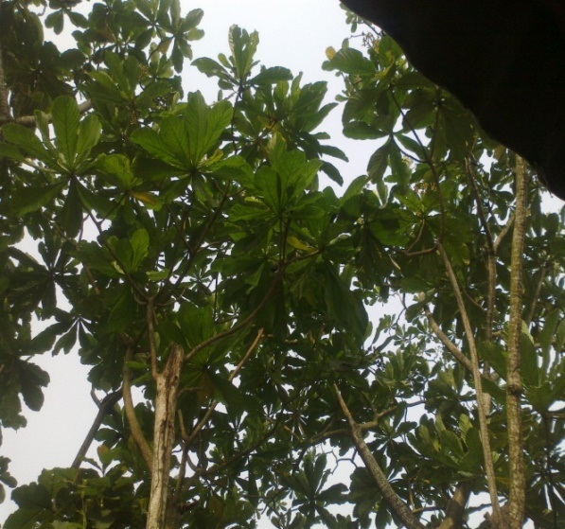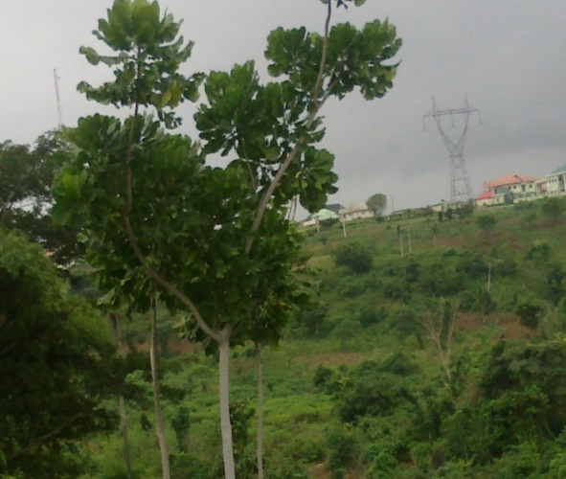
Plates 1: A. vogelii (Mag X4) Plates 2: A. nobilis (Mag X4)

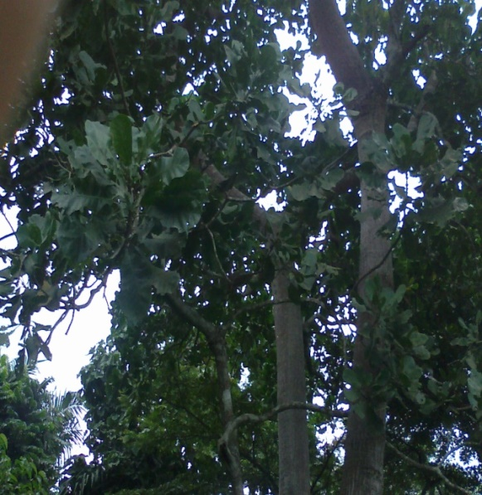
Plate 1b: A. djalonensis (Mag X4)

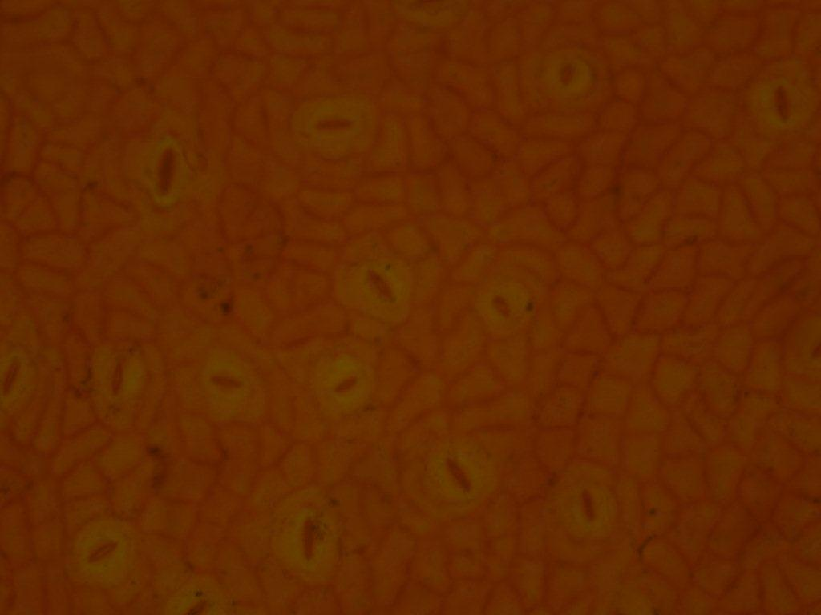 Plate 4a: Epidermal tissue in A. djalonensis (abaxial) Mag X10 Plate 4b: Epidermal tissue in A. djalonensis(abaxial) Mag X10

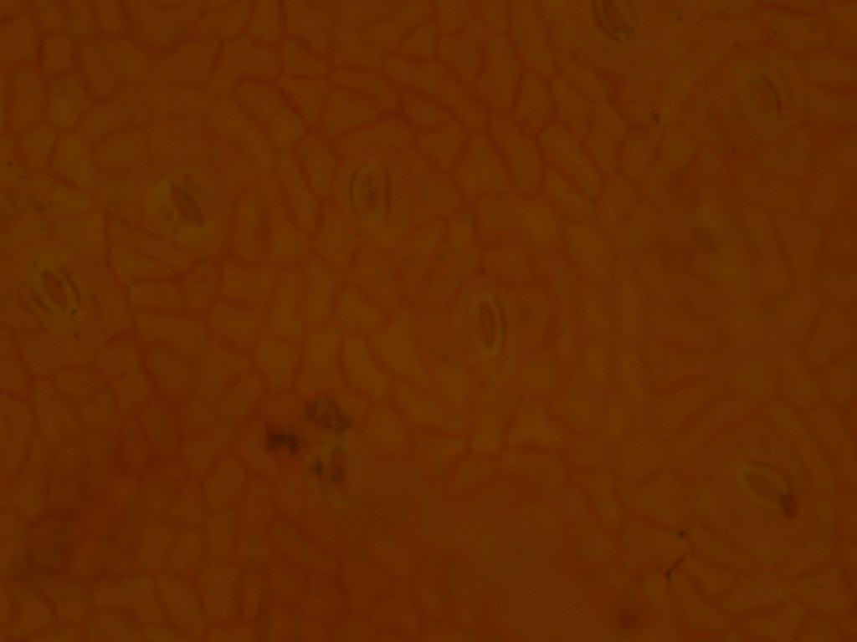 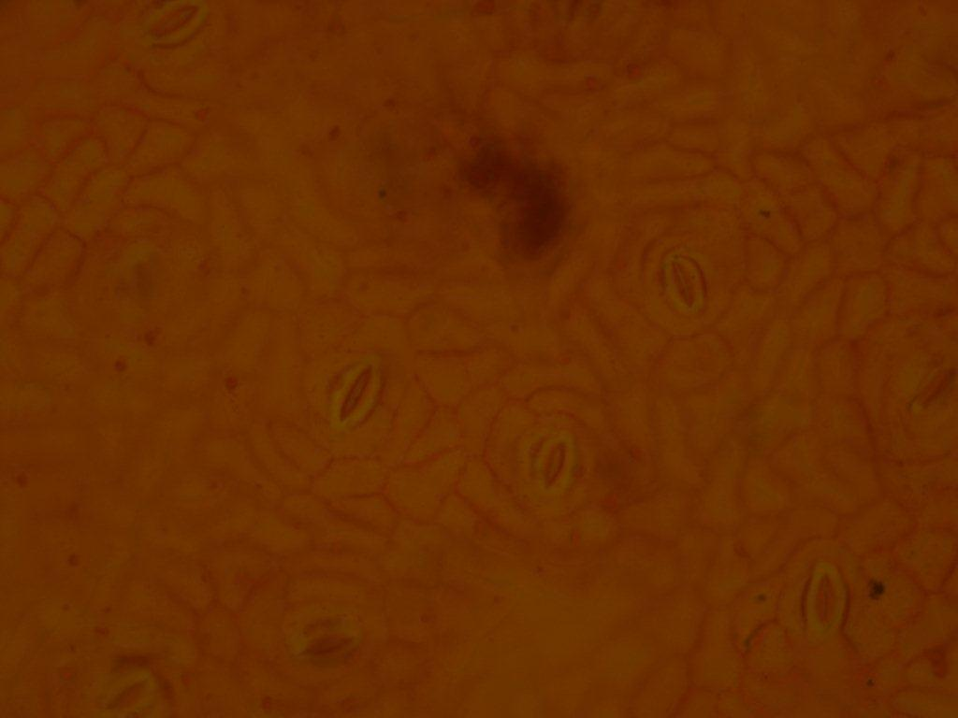 Plate 5a: Epidermal tissue in A. nobilis (abaxial) Mag X10 Plate 5b: Epidermal tissue in A. nobilis (adaxial) Mag X10

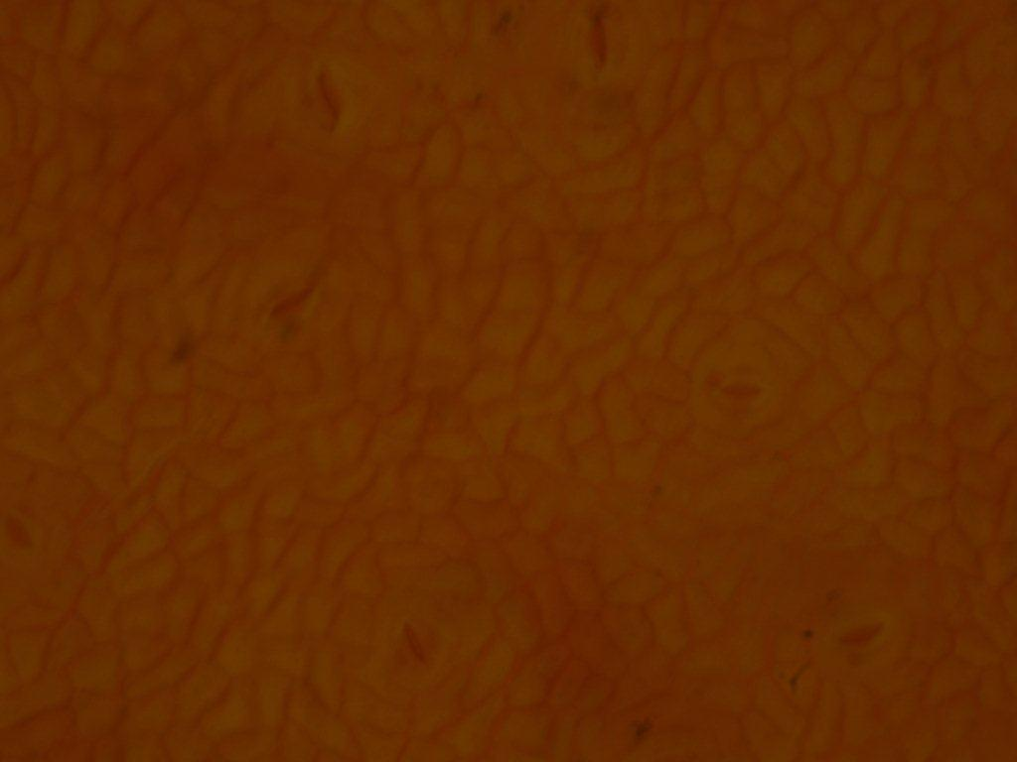 Plate 6a: Epidermal tissue in A. vogelii (abaxial) Mag X10 Plate 6b: Epidermal tissue in A. vogelii (adaxial) Mag X10

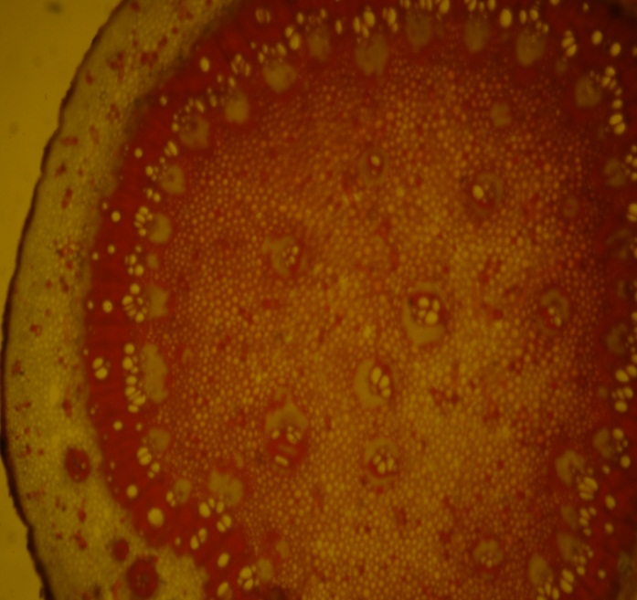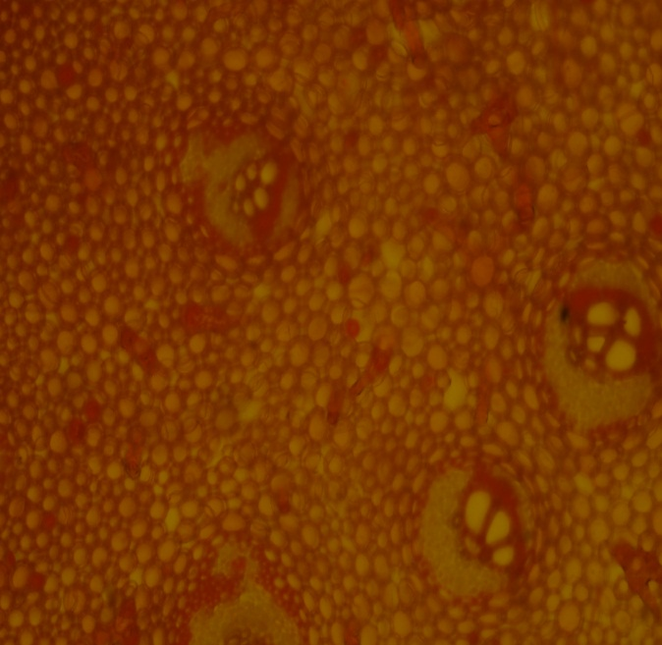
Plate 7a: Petiole of A. nobilis(X4) Plate 7b: Petiole of A. nobilis(X10)
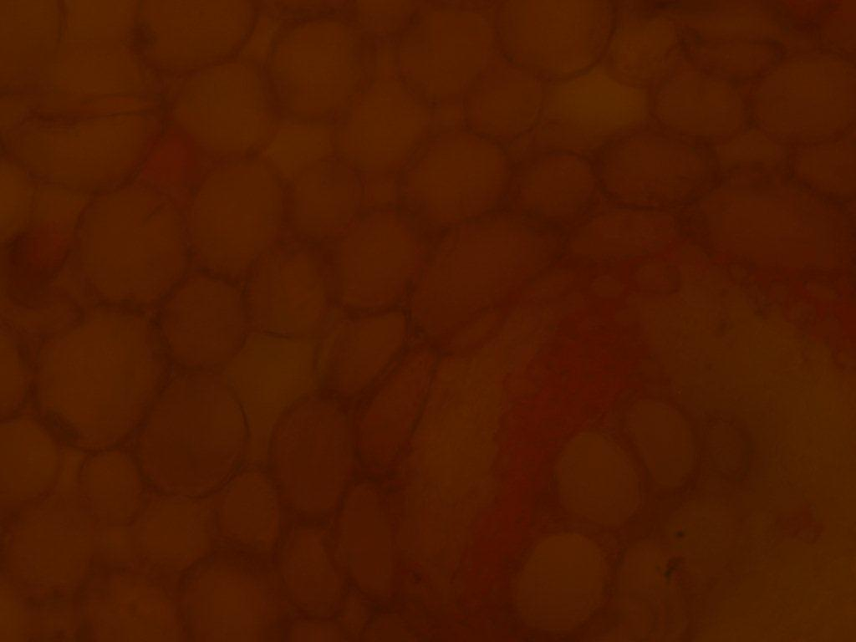
Plate 7c: Petiole of A. nobilis(X40)

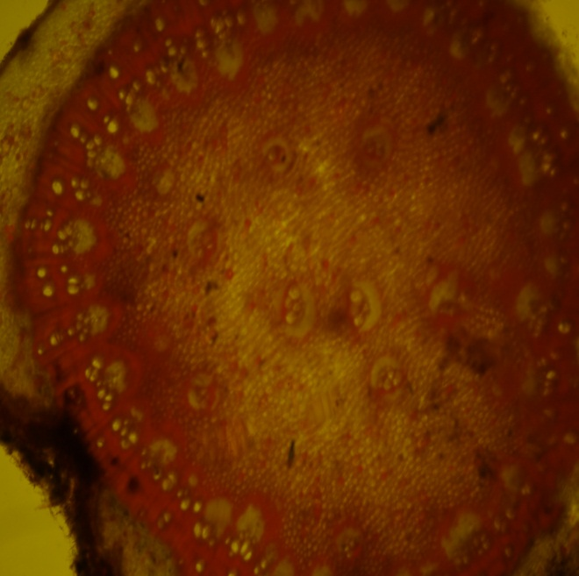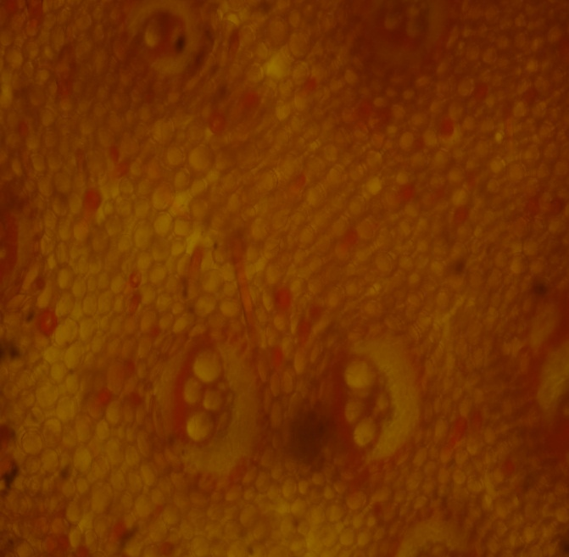
Plate 8a: Petiole of A. vogelii (X4) Plate 8b: Petiole of A. vogelii (X10)

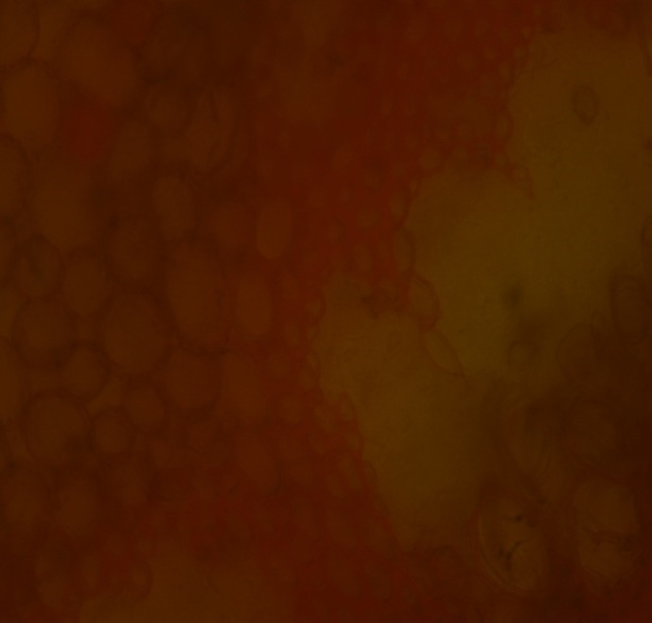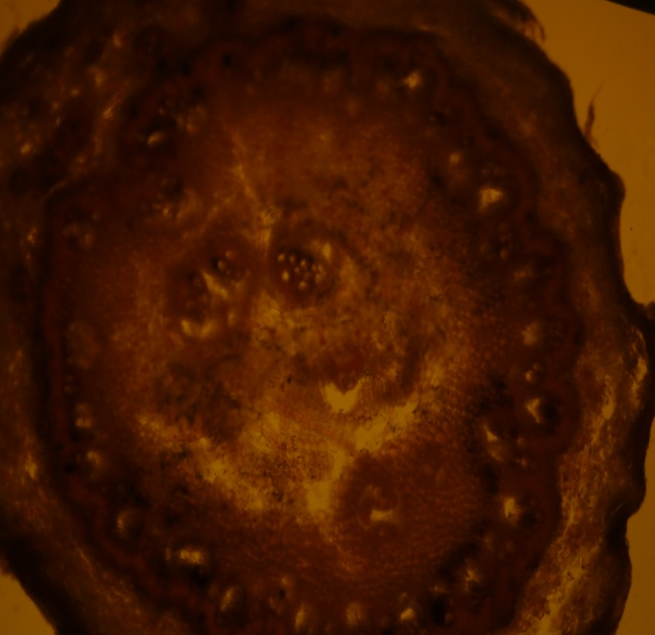
Plate 8c: Petiole of A. vogelii (X40) Plate 9a: Petiole of A. djalonensis (X4)
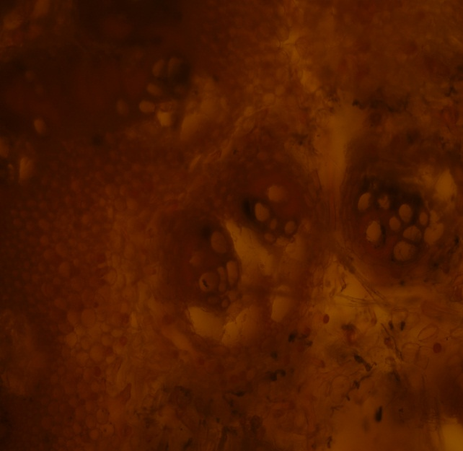
Plate 9b: Petiole of A. djalonensis (X10) Plate 9c: Petiole of A. djalonensis (X40)

