Diversity analysis of KAU released cocoa (Theobroma cacao L.) varieties based on morphological parameters
Sujith S Sajeevkumar¹, J. S. Minimol², P. M. Ajmal³ and B. Suma⁴
¹ Centre for Plant Biotechnology and Molecular Biology, Kerala Agricultural University, Thrissur, Kerala, India-680656
^{2, 4}Cocoa Research Centre, Kerala Agricultural University, Thrissur, Kerala, India-680656
³ Department of Plantation Crops and Spices, Kerala Agricultural University, Thrissur, Kerala, India-680656
¹Email: sssujith303@gmail.com, Mob No. 7025333804
Abstract
Holding the largest cocoa germplasm in Asia comprising of 632 accessions, Cocoa Research Centre (CRC), Kerala Agricultural University (KAU) has done immense research in cocoa and resulted in release of 10 varieties during its first phase. These varieties will form the parental material for establishment of poly clonal gardens. Seeds collected from these gardens will serves as the source for planting material all over cocoa growing tracts of India. As reported about self incompatibility, cross incompatibility is also a major constrain in cocoa research. Hence, understanding similarity or dissimilarity among the varieties before establishing clonal gardens is essential. Morphological analysis with respect to the selected quantitative and qualitative pod characteristics were taken into consideration for the analysis. Six qualitative and eight quantitative pod and bean characters of each varieties were recorded as per the standard descriptors. The genetic associations among the varieties were estimated through Jaccard’s similarity coefficients using NTSYSpc version 2.1. Cluster analysis was done on the similarity matrix and dendrogram was constructed using Unweighted Pair-Group Method (UPGMA). Diversity analysis based on qualitative and quantitative traits grouped the ten cocoa varieties into five clusters at 68 per cent similarity level. Homology between qualitative and quantitative clustering pattern was also worked out and the result shown significant variation in distribution pattern of varieties under study. The polyclonal garden layout designed based on the present diversity analysis can be made use of for ensuring maximum pod set when growing cocoa with coconut.
Key words: Cocoa, similarity, NTSYSpc, dendrogram, UPGMA, diversity, layout
INTRODUCTION
Cacao (Theobroma cacao L.) which referred to as ‘chocolate tree’ is an important cash crop in many tropical countries. In India, the regular germplasm introduction from University of Reading, England forms the genetic base of cocoa (Minimol and Prasnnakumari, 2013). In the country, cocoa is grown as a mixed crop with palm based cropping systems i.e., with coconut and arecanut in traditional zones of Kerala and Karnataka. In Tamil Nadu and Andhra Pradesh, cocoa is being an inter crop under coconut and to some extend in oil palm gardens (Alban et al., 2016). Morphological markers generally represent genetic polymorphisms based on visible traits, which are easily identified and manipulated. Investigations so far revealed that morphological markers are useful for classifying the diversity of cocoa populations and germplasm collections (Efombagn et al., 2009). Smith and Smith (1989) concluded that, morphological characterization is the first step in the description and classification of germplasm. Similarly, Minimol et al. (2011) reported that the fruit apex form plays an important role in determining fruit shape. So far, several studies of morphological diversity have been conducted on flowers, fruits and leaves of cocoa germplasm accessions (Asna et al., 2014). Domesticated T. cacao has a wide diversity in plant morphology and the three cocoa groups such as Criollo, Forastero and Trinitario were mainly classified based on their morphology especially the pod and bean characters (Wood and Lass, 1985). Exploiting the potential of Asia’s largest cocoa germplasm (640 accessions) maintained by Cocoa Research Centre (CRC), Kerala Agricultural University (KAU), the centre has conducted immense research and released 10 cocoa varieties on its initial phase. In India, 90 percent of cocoa gardens are established with the planting materials supplied from KAU (Sujith and Minimol, 2016). Hence, the morphological analysis on pod and bean characters of released cocoa varieties from the research centre will be the basis of future crop improvement programs.
MATERIALS AND METHODS
Ten varieties released from CRC, KAU viz. CCRP1, CCRP2, CCRP3, CCRP4, CCRP5, CCRP6, CCRP7, CCRP8, CCRP9 and CCRP10 has been included in the study. For the present investigation, six qualitative and eight quantitative pod parameters were recorded based on standard descriptors.
Analysis of qualitative traits
Six qualitative characters viz. colour of ripe pods, pod shape, pod apex form, basal constriction, pod rugosity and colour of bean were recorded on five pods in each variety collected at random. The genetic associations among the varieties were estimated through Jaccard’s similarity coefficients (Jaccard, 1908) using NTSYSpc version 2.1 (Rohlf, 1992). Cluster analysis was done on the similarity matrix and a dendrogram was constructed using Unweighted Pair - Group Method (UPGMA) (Sneath and Sokal, 1973).
Analysis of quantitative traits
Eight quantitative characters viz. pod weight (g), pod length (cm), pod breadth (cm), husk thickness (cm), wet bean weight (g), number of beans per pod, single wet bean weight (g) and single dry bean weight (g) were recorded. Further analysis was done using completely randomized design (CRD) and computed the data for all the individual characters observed. Clustering based on quantitative characters was done using NTSYSpc version 2.1 and a dendrogram was constructed using UPGMA.
Cluster analysis
Cluster analysis was done on the similarity matrix and dendrogram was constructed using UPGMA. Both qualitative and quantitative data subjected for cluster analysis grouped the varieties in to five clusters at 68 per cent similarity.
RESULTS AND DISCUSSION
Morphological observations on distinguishable quantitative and qualitative characters were recorded on five pods collected from each variety using reported descriptors (Bekele and Butler, 2000). The values thus obtained were averaged on cluster basis and compared the similarity or dissimilarity among clusters on specific character. Ten varieties included seven selections (CCRP 1, CCRP 2, CCRP 4, CCRP 4, CCRP 5, CCRP 6, and CCRP 7) and three hybrids (CCRP 8, CCRP 9 and CCRP 10).
Analysis of qualitative traits
Agglomerative hierarchical clustering based on Jaccard’s similarity coefficient was done using the UPGMA method with 6 qualitative characters. Dendrogram was constructed and presented in Fig 1. Ten varieties grouped into five clusters at 68 percent similarity level (Table 1). Cluster I consisted of maximum number of members i.e., five (CCRP 1, CCRP 7, CCRP 8, CCRP 9 and CCRP 10). Clusters II, III and V had single varieties each i.e., CCRP 2, CCRP 3 and CCRP 6 respectively. Members of cluster IV included CCRP 4, and CCRP 5. Hybrids CCRP 8, CCRP 9 and CCRP 10 grouped in single cluster. Table 2 depicts cluster based qualitative observations made on the varieties under study. All the members of cluster I except CCRP 7 possessed pods of cundeamor shape, medium rugosity, acute pod apex and dark purple beans. Cluster IV had CCRP 4 and CCRP 5 with angoleta shaped yellow pods, intense pod rugosity and dark purple beans. Though CCRP 2 and CCRP 3 grouped in to two different clusters, except pod apex form, they were similar in all other five characters. Cluster V consisted of single variety CCRP 6 which was different from CCRP 4 and CCRP 5 with respect to colour of ripe pod and pod rugosity.

Clusters IV and V were of angoleta (oval) type and varieties under cluster I which comprises hybrids CCRP 8, CCRP 9 and CCRP 10 produced cundeamor (ridged and with bottle neck) shaped pods. Cluster II and III produced amelonado (melon shaped) shaped pods. Cluster IV and V with angoleta shaped pod expressed obtuse end indicating fruit shape can be identified by its apex form. The results were in tune with the early study by Minimol et al. (2011) stating that fruit shape is influenced by fruit apex. The other characters like rugosity and colour of cotyledon also support the fact that all the varieties were forastero types. Rugosity was medium except CCRP 6 (intense) and colour of cotyledon ranged from pink to dark pink. The same features were described by Wood and Lass, (1985) for forastero types.
Analysis of quantitative traits
The ten varieties differed significantly with respect to all the eight quantitative characters viz. pod weight, pod length, pod breadth, husk thickness, number of beans, wet bean weight/pod, single wet bean weight and single dry bean weight (Sujith and Minimol, 2016). The phylogenetic tree constructed at 68 per cent similarity level grouped the varieties under study in to five clusters (Fig. 2). Among the five clusters generated, cluster III, cluster IV and cluster V comprised of single variety CCRP 5, CCRP 6 and CCRP 9 respectively (Table 3). Significant difference was expressed for pod weight among different clusters. The highest pod weight was recorded in cluster IV (608.84 g) followed by cluster III (486.20 g) and cluster I (480.15 g) which were almost on par (Table 4). The least pod weight recorded was 383.52 g by cluster II comprised of CCRP 2 and CCRP 3 (Table 5). However all the varieties expressed pod weight more than 350 g which is the selection criteria recommended by Francies et al. (2002). Cluster IV (CCRP 6) was found to yield pods with an average of 18.82 cm length and was found maximum. Whereas, hybrid CCRP 9 (cluster V) produced small pods with average pod length of 12.83 cm. The highest pod breadth of 9.12 cm was recorded for CCRP 6 (9.12 cm) and minimum was observed in CCRP 9 (6.93 cm). Length and breadth of the pods were found to be proportional. Husk thickness had a significant role in deciding pod weight (Rubeena, 2015). Husk thickness of one cm or less than one cm is the desirable character (Enriquez and Soria, 1966) and all the five clusters were on par with optimum husk thickness.

The average number of beans per pod was recorded and found diverse among the clusters. However there was no significant difference found among members of clusters I and cluster III with highest bean count. Large number of beans alone cannot consider as a selection criteria. More number of beans with less weight may yield less butter content. Yield expressed as wet or dry bean weight is highly variable (Pound 1932; Enriquez and Soria, 1966). Maximum wet bean weight is expressed by cluster IV (CCRP 6) with 142.86 g and the least was recorded by cluster II weighing 67.42 g (Table 4). The most important economic part of cocoa is beans. Size of bean is considered as one of the important component of yield in cocoa (Soria, 1978). Bean characters expressed variations with in the species (Adewale et al., 2010). However in the present study the peeled dry weight of single bean of all the varieties was more than 0.8 g which is the accepted standard (Wood and Lass, 1985).
Comparative clustering on qualitative and quantitative data
Homology between qualitative and quantitative clustering pattern was worked out for the varieties studied and presented (Table 5). Distribution pattern of varieties based on qualitative and quantitative clustering varied. In cluster I, CCRP 1, CCRP 7, CCRP 8 and CCRP 10 were common in both qualitative and quantitative clustering. Hybrids CCRP 8 and CCRP 9 were grouped in a single cluster with respect to qualitative data, but in case of quantitative clustering they were grouped into cluster I and cluster V respectively.

Genotypes of same genetic constitution will show cross incompatibility and finally will result in reduction in yield (Mallika et al., 2002). Hence while designing a poly clonal garden or planting bud woods for commercial cultivation care should be taken not to plant varieties falling in same cluster nearby. A proposed field lay out of cocoa as intercrop in coconut plantation is designed and depicted in fig 3. Following the same pattern or slight modification of the designs as per the availability of varieties can be employed for minimizing self incompatibility issues and thus for ensuring maximum pod set.

CONCLUSION
Released varieties of KAU forms the basic planting material of cocoa polyclonal garden in the country. In order to obtain maximum pod set out of them, it is very much essential to design a layout by keeping maximum divergent parents together. The present investigation was one such successful effort to study and design a polyclonal garden layout. More over the designed layout will also help the farmers to set their cocoa garden with budded plants of released varieties. This will in turn result in maximum exploitation of yield potential of the varieties.
ACKNOWLEDGMENTS
We thank the PG scholarship by Kerala Agricultural University (KAU) during the course of the research. We also thank the facilities at Cocoa Research Centre (CRC), Cocoa Farm Office and Department of Agricultural Statistics, College of Horticulture, KAU towards the successful completion of the research.

REFERENCES
Adewale, B. D., Okonji, C., Oyekanmi, A. A., Akintobi, D. A. C. and Aremu, C. O. 2010. Genetic variability and stability of some grain yield components of cowpea. Afr. J. Agric. Res. 5: 874-880.
Alban, M. K. A., Apshara, S. E., Hebbar, K. B., Mathiyas, T. G. and Severin, A. 2016 Morpho-physiological criteria for assessment of two month old cocoa (Theobroma cacao L.) genotypes for drought tolerance. Ind. J. Plant Physiol. 21(1): 23-30.
Asna, A. C., Prasnnakumari, K. T., Minimol, J. S. and Krishnan, S. 2014. Variability analysis in bean characters of selected accessions of cocoa (Theobroma cacao L.). J. Plant. Crops. 42(2): 246-251.
Bekele, F. L. and Butler, D. R. 2000. Proposed short list of cocoa descriptors for characterization. In: Eskes, A. B., Engels, J. M. M. and Lass, R. A. (Eds.), Working Procedures for Cocoa Germplasm Evaluation and Selection. Proceedings of the CFC/ICCO/IPGRI project workshop, Montpiller, France, pp. 41-48.
Efombagn, M. I. B., Sounigo, O., Nyasse, S., Manzanares-Dauleux, M. and Eskes, A. B. 2009. Phenotypic variation of cacao (Theobroma cacao L.) on farms and in the gene bank in Cameroon. J. Plant Breed. Crop Sci. 1(6): 258-264.
Enriquez, C. G. A. and Soria, V. J. 1966. Estudio de la variabile de varies characteristicas delar mazereas de cocoa (Theobroma cacao L.). Fitotecnia Latino - Americana, 3(1): 99-118.
Francies, R. M., Oomen, A., Mallika, V. K., and Nair, V. R. 2002. Selection indices in cocoa (Theobroma cacao L.). In: Bhat, R., Balasimha, D., and Jayasekhar, S. (Eds.), Technologies for Enhancing Productivity in Cocoa. Proceedings of a National Seminar, 29-30 November 2002. Vittal, Karnataka. Central Plantation Crops Research Institute, India, pp. 29-30.
Jaccard, P. 1908. Nourelles recherché sur la distribution florale. Bull. Vaud. Sci. Nat. 44: 223-270.
Mallika, V. K., Amma, S. P., Nair, R. V. and Namboothiri, R. 2002. Cross-compatibility relationship within selected clones of cocoa. In: Proceedings of seminar on strategies for enhancing productivity of cocoa, 29-30 November 2002. Ravi, B., Balasimha, D., and Jayasankar, S. (Eds.), Central Plantation Crops Research Institute, Regional station, Vittal, Karnataka, pp. 19-27.
Minimol, J. S. and Prasannakumari, A. S. 2013. Self-incompatibility assessment in vascular streak dieback (VSD) disease resistant hybrids of cocoa (Theobroma cocoa L.). Asian J. Hortic. 8(1): 114-117.
Minimol, J. S., Amma, S. P., Krishnan, S. and Vasudevan, N. R. 2011. Influence of fruit apex on fruit shape in selected accessions of cocoa. In: Proceedings of seminar on strategies for enhancing productivity of cocoa, 28-29 January 2011, Central Plantation Crops Research Institute, Regional station, Vittal, Karnataka. pp. 23-25.
Pound, F. J. 1932. The genetic constitution of the cocoa crop. In: First Annual Report on Cocoa Research for 1931. Trinidad and Tobago, pp. 25-28.
Rohlf, F. J. 1992. NTSYSpc. Numerical Taxonomy and Multivariate Analysis System Version 2.0. Department of Ecology and Evolution, State University of New York. 38p.
Rubeena, M. 2015. Analysis of bean characters in cocoa (Theobroma cacao L.) hybrids bred for bold beans. MSc Thesis. Kerala Agricultural University, Thrissur, Kerala, 63p.
Smith, J. S. C. and Smith, O. S. 1989. The description and assessment of distances between inbred lines of maize: The utility of morphological, biochemical, and genetic descriptors and a scheme for the testing of distinctiveness between inbred lines. Maydica. 34: 151-161.
Sneath, P. H. and Sokal, R. R. 1973. Numerical taxonomy: the principles and practice of numerical classification. San Francisco, Freeman, 573 p.
Soria, V. J. 1978. The breeding of cacao (Theobroma cacao L.) Trop. Agric. Res. Ser. 11: 161-168.
Sujith, S. S. and Minimol, J. S. 2016. Kerala Agricultural University (KAU) Released Cocoa Varieties. Advances in Life Sciences. 5(16), Print: ISSN 2278-3849, pp. 6258-6261.
Wood, G. A. R and Lass, R. A. 1985. Cocoa. 4th edn. Tropical Agriculture Series, Longman Publications, New York, 620p.

Table 1. Clustering based on qualitative characters for cocoa varieties
Cluster no | No. of varieties | Name of varieties
I | 5 | CCRP 1  CCRP 7  CCRP 8  CCRP 9  CCRP 10
II | 1 | CCRP 2
III | 1 | CCRP 3
IV | 2 | CCRP 4  CCRP 5
V | 1 | CCRP 6

Table 2. Qualitative characters of 10 cocoa varieties
Cluster ID/ Observations | Pod shape | Colour of ripe pod | Pod apex form | Pod basal constriction | Pod rugosity | Colour of bean
I | Cundeamor | Greenish yellow | Acute | Slight | Medium | Dark purple
II | Amelonado | Yellow | Rounded | Slight | Medium | Light purple
III | Amelonado | Yellow | Acute | Slight | Medium | Dark purple
IV | Angoleta | Yellow | Obtuse | Slight | Intense | Dark purple
V | Angoleta | Yellowish green | Obtuse | Slight | Medium | Light purple
Table 3. Clustering based on quantitative characters of cocoa varieties
Cluster no | No. of cluster members | Cluster members
I | 5 | CCRP 1  CCRP 4  CCRP 7  CCRP 8  CCRP 10
II | 2 | CCRP 2  CCRP 3
III | 1 | CCRP 5
IV | 1 | CCRP 6
V | 1 | CCRP 9

Table 4. Mean values of yield contributing characters of 10 cocoa varieties
Cluster ID/ Observations | Pod weight (g) | Pod length (cm) | Pod breadth (cm) | Husk thickness (cm) | Number of beans | wet bean weight (g) | Dry bean weight/ single seed (g) | Wet bean weight/ single seed (g)
I | 480.15 | 15.61 | 8.11 | 0.92 | 41.24 | 115.57 | 0.90 | 2.82
II | 383.52 | 13.82 | 8.29 | 0.85 | 37.40 | 74.64 | 0.82 | 1.99
III | 486.20 | 16.36 | 8.78 | 0.91 | 42.80 | 116.10 | 0.86 | 2.76
IV | 608.84 | 18.82 | 9.12 | 0.95 | 39.60 | 132.78 | 1.09 | 3.35
V | 510.50 | 12.83 | 6.93 | 0.82 | 31.80 | 107.35 | 0.77 | 3.38

Table 5. Homology between qualitative and quantitative clusters
Qualitative cluster | No. of varieties | Quantitative cluster
 |  | I | II | III | IV | V
I | 5 | 80  (CCRP1, CCRP 7, CCRP 8 CCRP 10) | - | - | - | 20  (CCRP 9)
II | 1 | - | 100 (CCRP 2) | - | - | -
III | 1 | - | 100 (CCRP 3) | - | - | -
IV | 2 | 50  (CCRP 4) | - | 50  (CCRP 5) | - | -
V | 1 | - | - | - | 100 (CCRP 6) | -

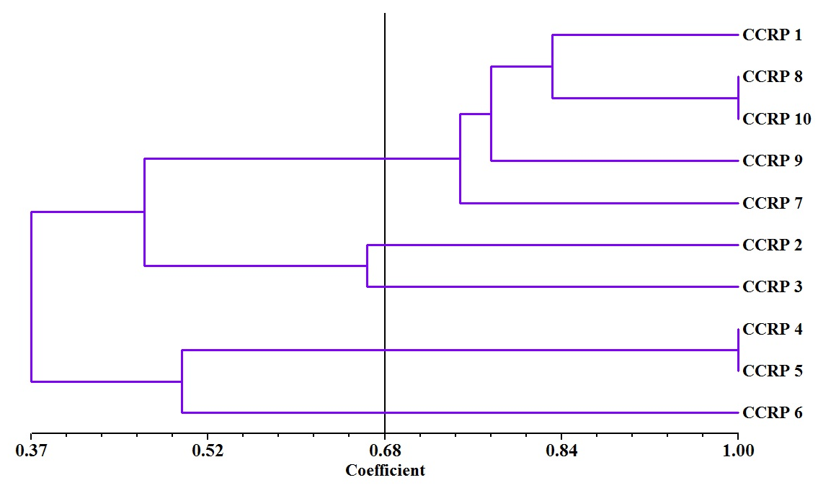
Fig 1. Dendrogram based on qualitative characters of 10 cocoa varieties
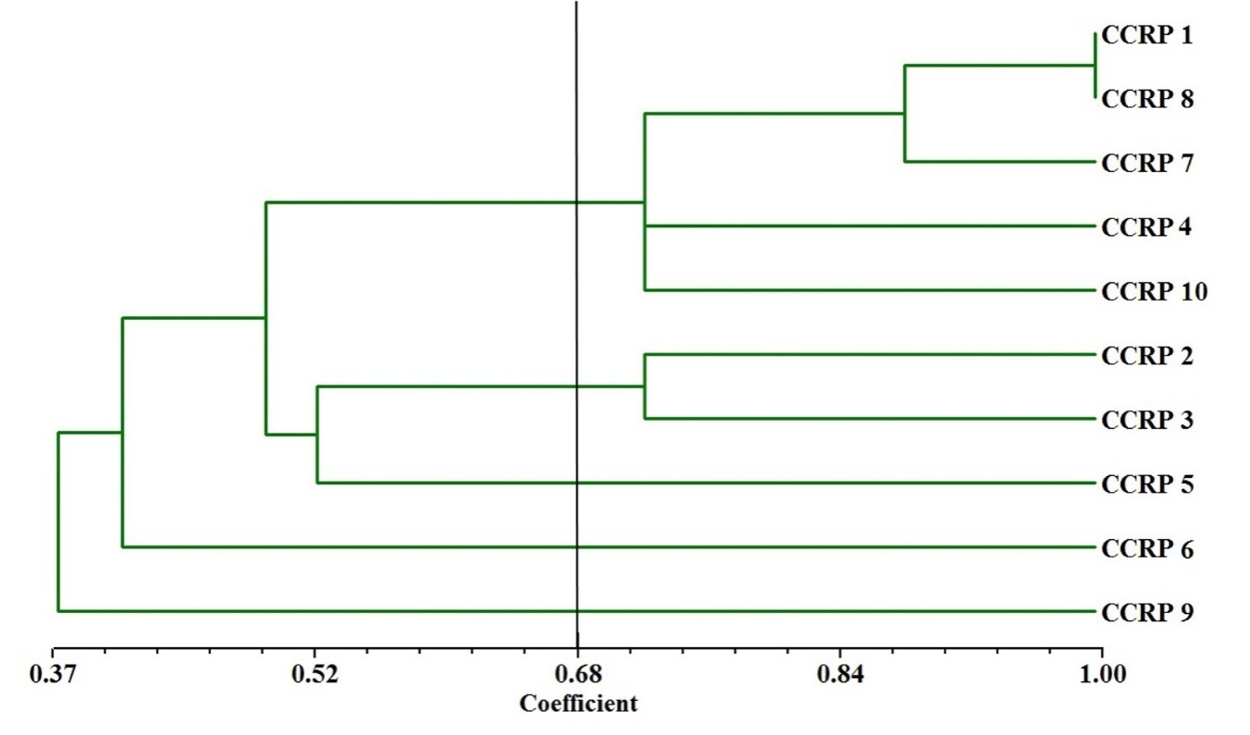
Fig 2. Dendrogram based on quantitative characters of 10 cocoa varieties
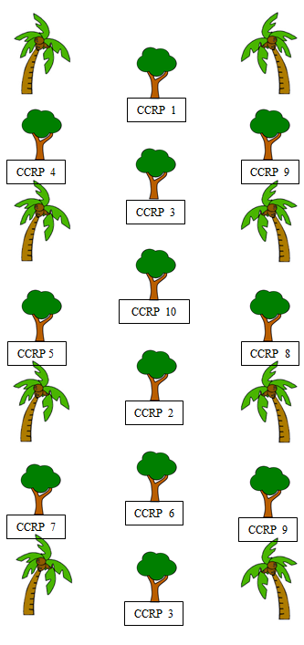
Fig 3. Proposed layout of cocoa as intercrop in coconut plantation

