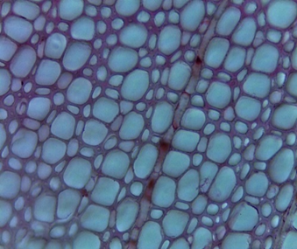
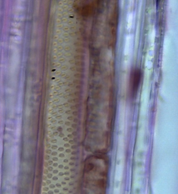
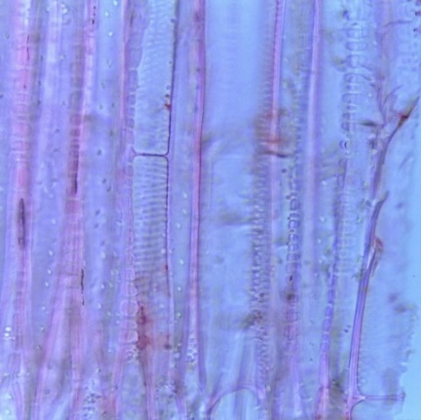
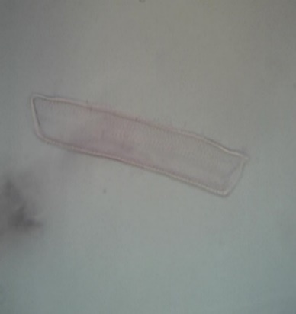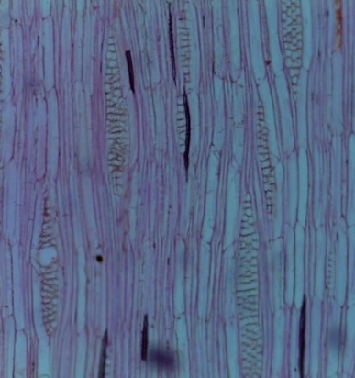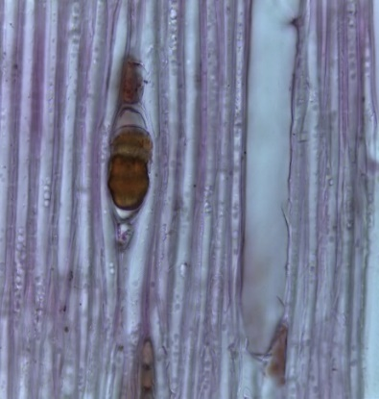
c
b
a
e
d

e
f
d

Fig. 1. Wood anatomical features of Aegiceras corniculatum showing vessels with simple perforation plates and transverse end tail (1a); rays of homogeneous type II with frequency of 6/mm² (1b); break down areas in rays with sclereid-like substance (1 c); vessels in diagonal or radial multiples (1 d); helical thickenings adjacent to vessel elements (1 e) and vestured pits in vessels ( 1f).

