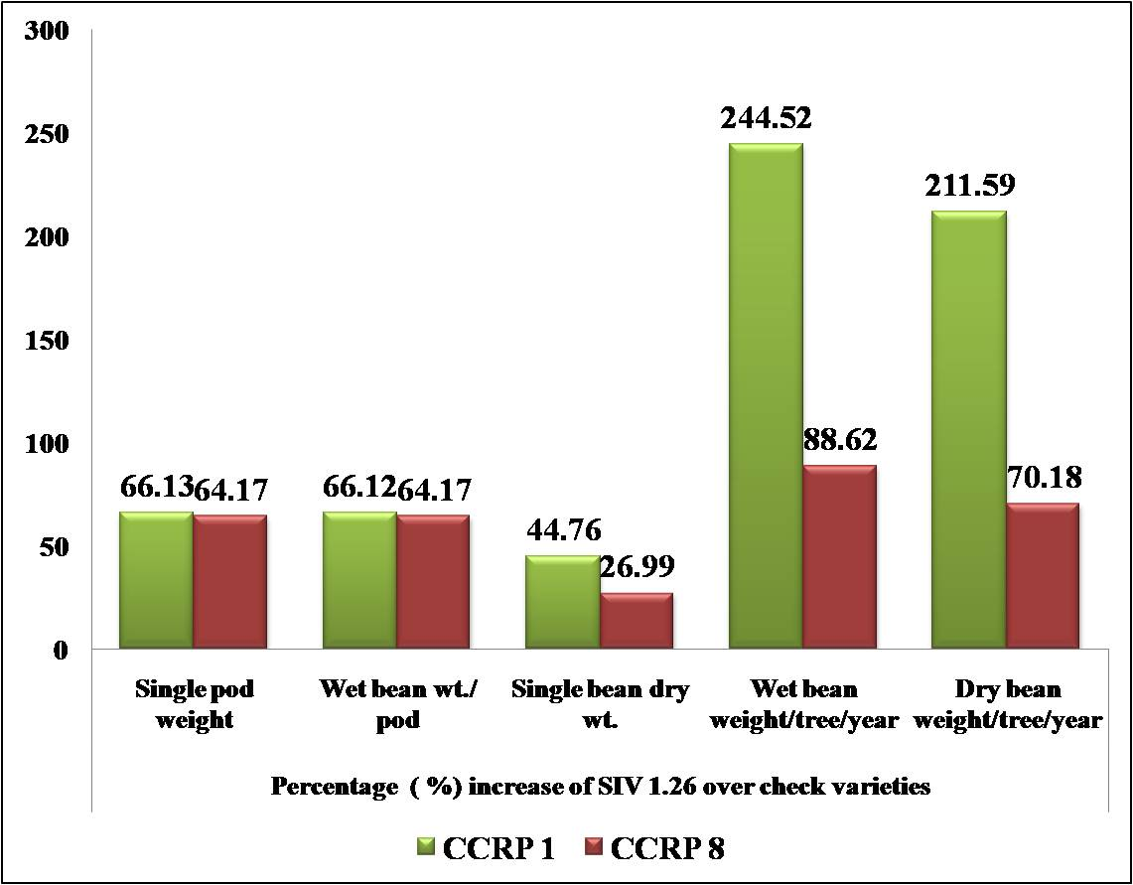
Figure 1. Percentage increase of yield contributing characters of SIV 1.26 over the checks CCRP 1 and CCRP 8

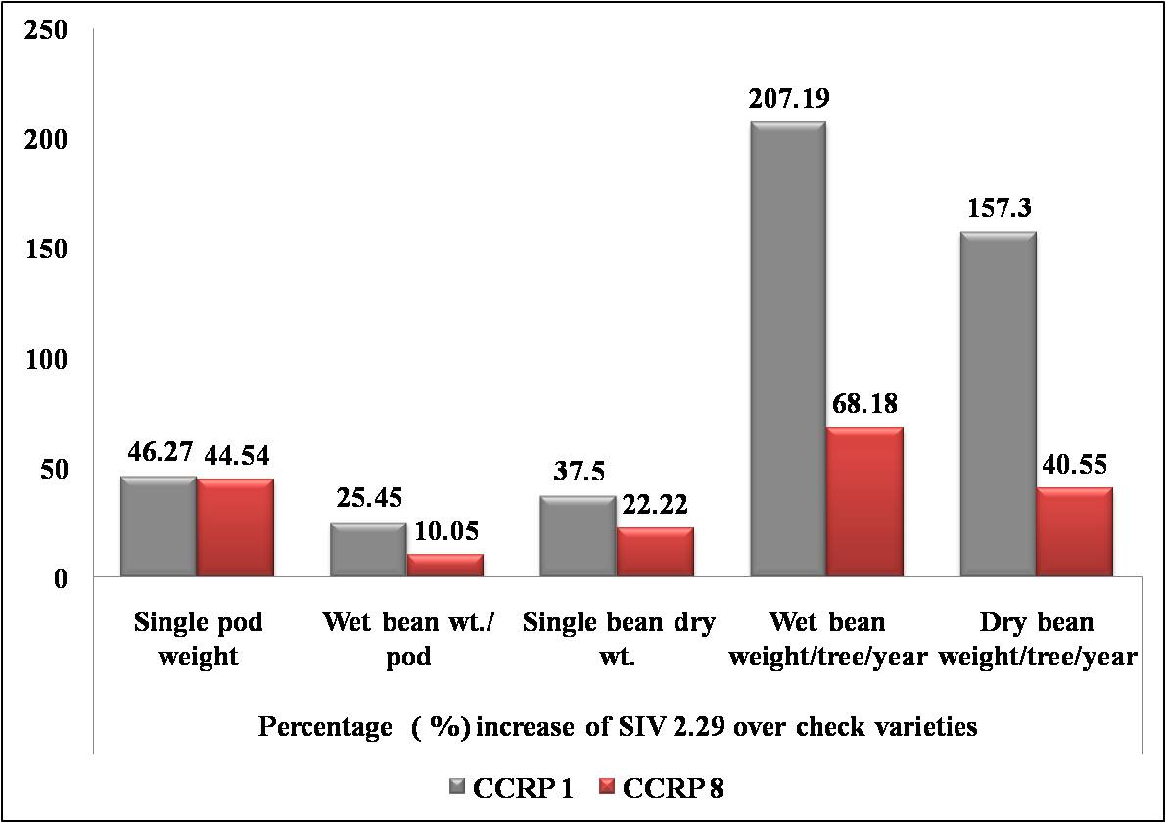
Figure 2. Percentage increase of yield contributing characters of SIV 2.29 over the checks CCRP 1 and CCRP 8
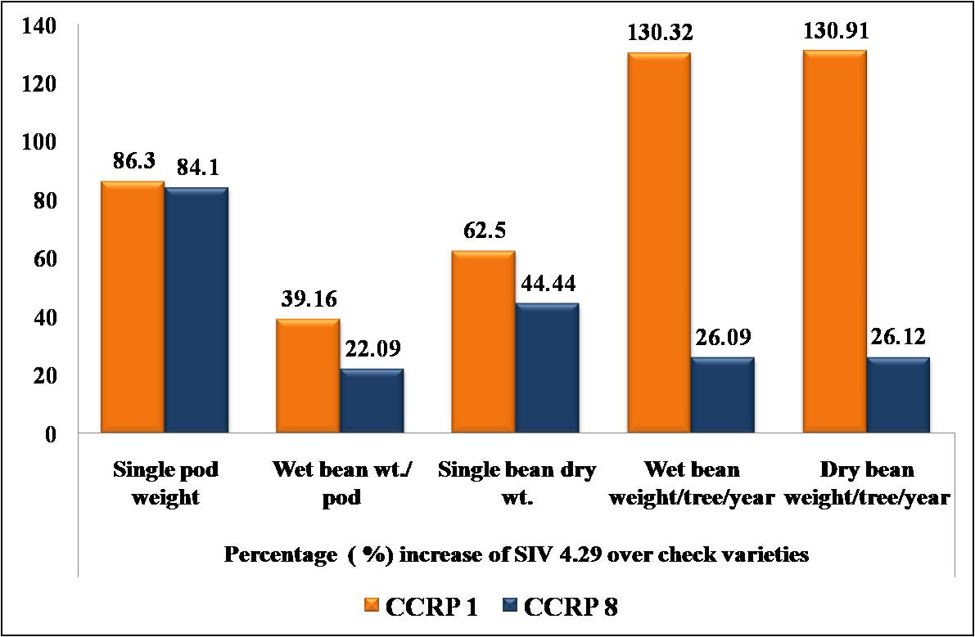
Figure 3. Percentage increase of yield contributing characters of SIV 4.29 over the checks CCRP 1 and CCRP 8
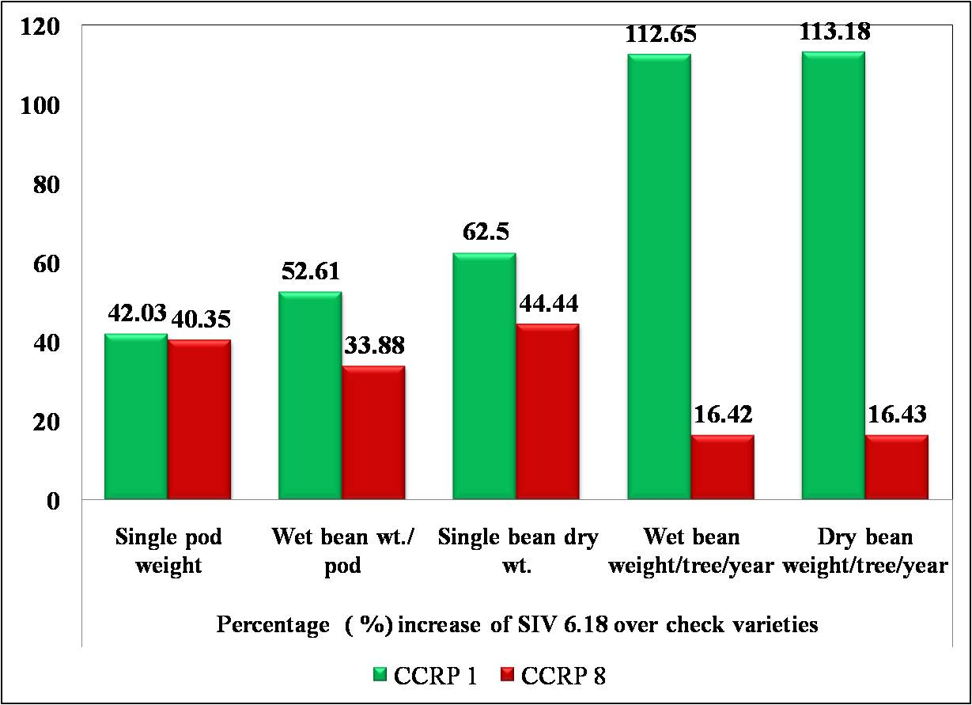
Figure 4 Percentage increase of yield contributing characters of SIV 6.18 over the checks CCRP 1 and CCRP 8

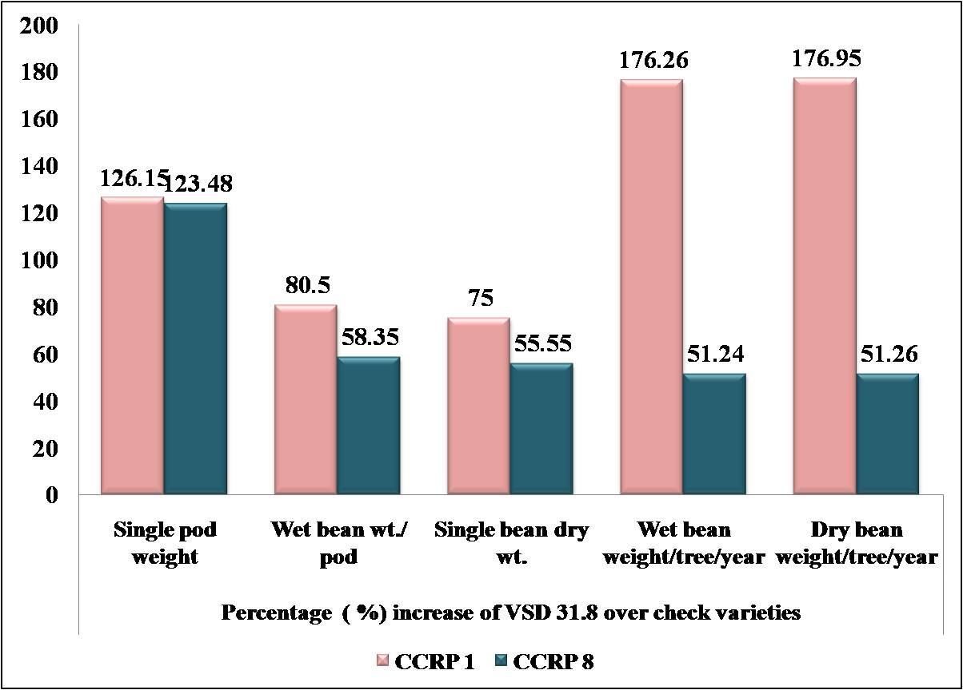

Figure 5 Percentage increase of yield contributing characters of VSD 31.8 over the checks CCRP 1 and CCRP 8

