

**INDIA**

**Fig 1. Map showing study area**

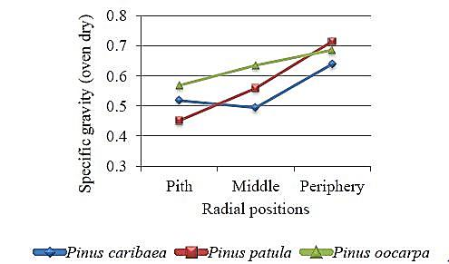

**Fig 2. Radial variation in mean specific gravity (oven dry) of pine species averaged over all ages**



**Fig 3. Radial variation in mean tracheid diameter of pine species averaged over all ages**



**Fig 4. Radial variation in mean tracheid wall thickness of pine species averaged over all ages**

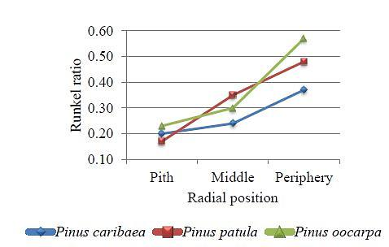

**Fig 5. Radial variation in mean Runkel ratio of pine species averaged over all ages**

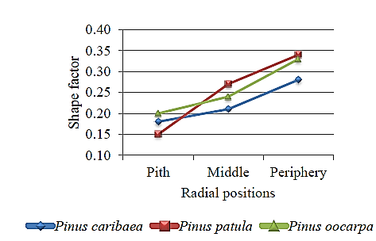

**Fig 6. Radial variation in mean shape factor of pine species averaged over all ages**

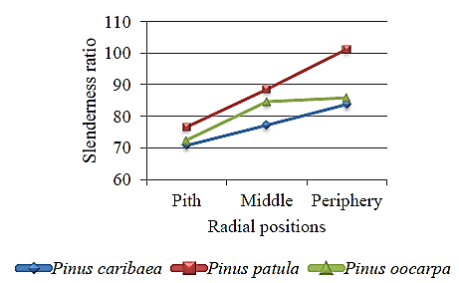

**Fig 7. Radial variation in mean slenderness ratio of pine species averaged over all ages**

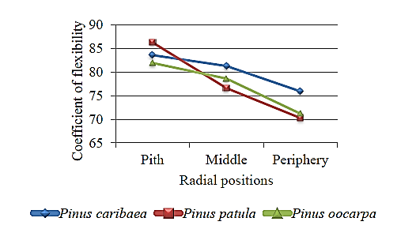

**Fig 8. Radial variation in mean coefficient of flexibility of pine species averaged over all ages**

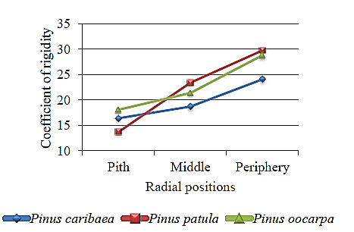

**Fig 9. Radial variation in mean coefficient of rigidity of pine species averaged over all ages**