Population Ecology and ETs Based Time Series for Climate Smart Management of Spilosoma obliqua Walkar on Two Types of Jute

Nayan Roy¹
¹Ecology Research Unit, M. U. C. Women’s College, Department of Zoology, Burdwan-713104, West Bengal, India. Fax: 0342-2531900; email:nayan909@gmail.com, orcid.org/0000-0002-0114-0596

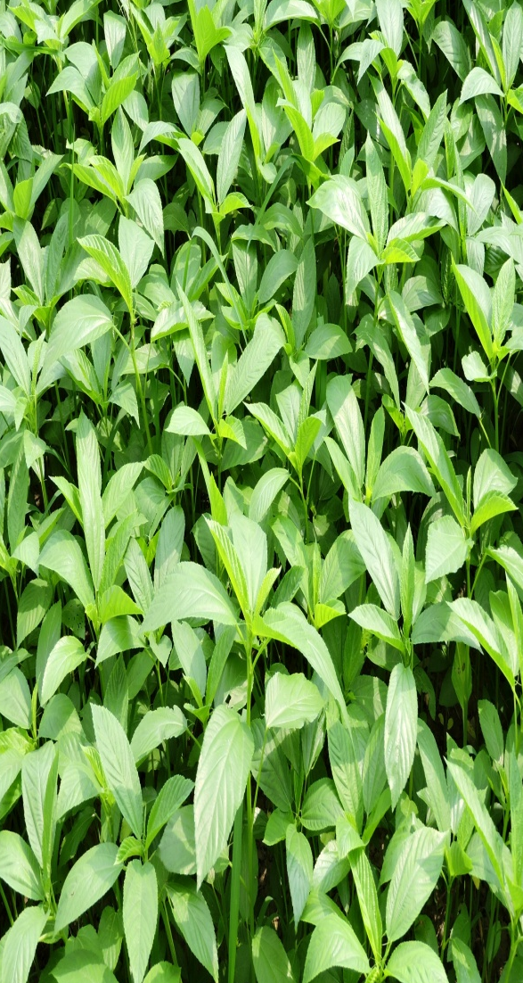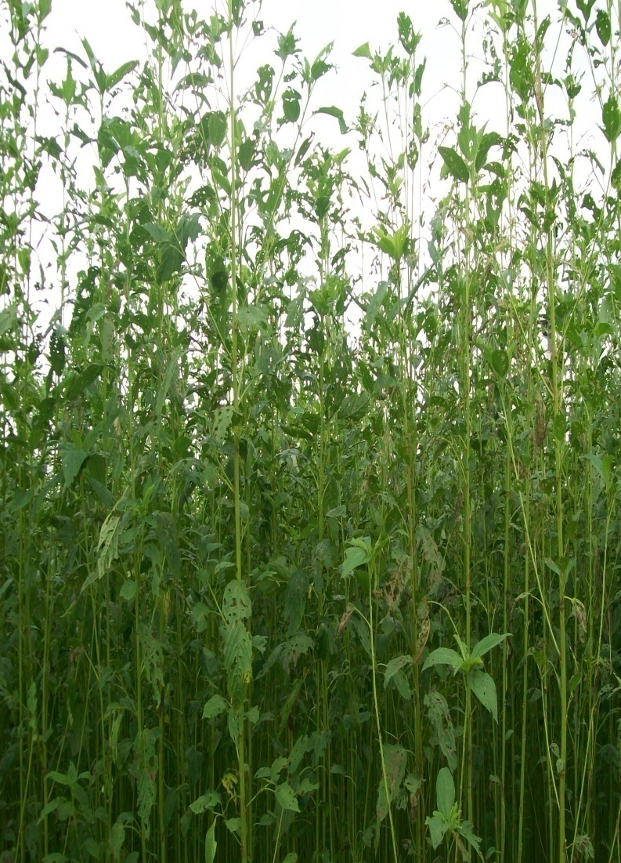

Figure A. Photographs representing tender jute plants and defoliation of jute leaves during their growth by the neonates of S. obliqua in field condition.

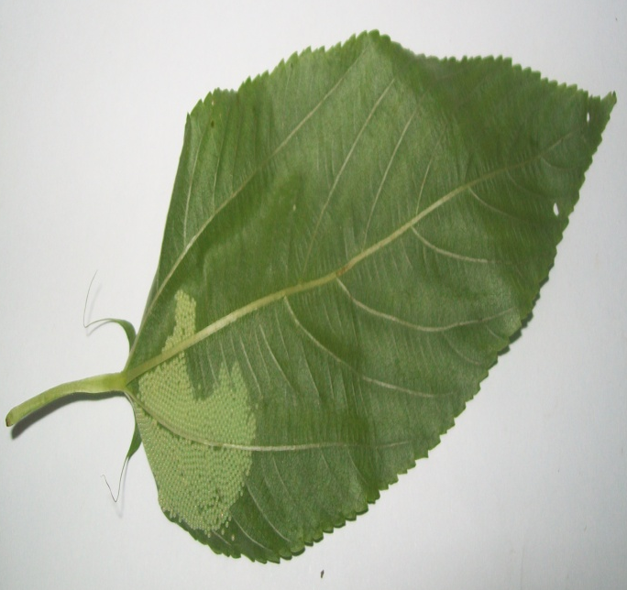

- (b)

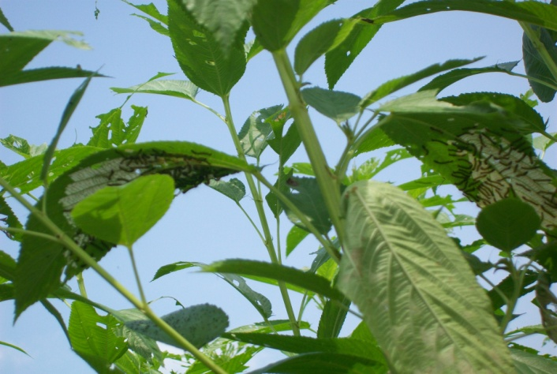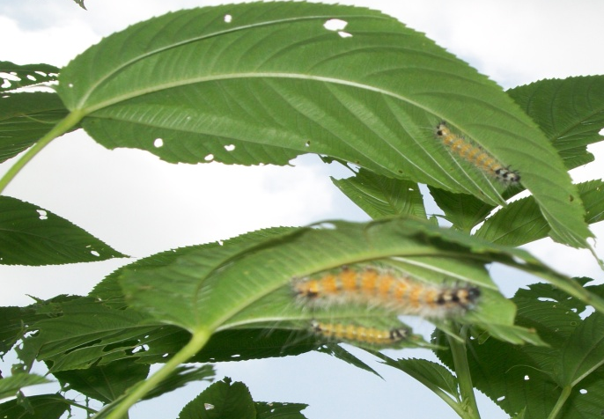
(c) (d)

Figure B. The photographs(a,b,c,d) showing S. obliqua adults [a] (Small male and large female), eggs [b], second [c] and third to fifth [d] instar larvae, respectively on jute crops.

